**The Potential Impact of the H. Pylori Infection on the Development of Colorectal Carcinoma.**

**Zaid Al-Mashahedi1*, Essam Mohammed Abdullah 2 and Maher Ali Jasim1**

1 College of Medicine, University of Anbar, Anbar, Iraq

2 College of Pharmacy, University of Anbar, Anbar, Iraq

|  |  |  |
| --- | --- | --- |
| **Article Info** |  | **ABSTRACT** |
| ***Article history:***  Received May, 06, 2025  Revised June, 18, 2025  Accepted July, 27, 2025 |  | This cross-sectional study investigated the association between *Helicobacter pylori* (*H. pylori*) infection and histopathological subtypes of colorectal lesions in 40 symptomatic patients. Serological (ELISA) and immune-histochemical (IHC) methods were employed to detect *H. pylori*. Demographically, the cohort exhibited male predominance (77.5%) and a mean age of 50.45±17.27 years. Adenocarcinoma was the most prevalent histopathological subtype (27.5%), followed by ulcerative colitis with adenomatous polyps (12.5%). IHC detected *H. pylori* in 57.5% of patients, surpassing serology (47.5%), which demonstrated low sensitivity (34.78%) and specificity (35.29%). Serum *H. pylori* positivity significantly correlated with adenocarcinoma (p=0.015), suggesting systemic involvement in carcinogenesis, whereas IHC showed no tissue-specific association (p=0.363), but it indicate direct involvements of the bacteria in development of CRC. These findings underscore IHC’s diagnostic superiority and propose systemic *H. pylori* status as a potential biomarker for adenocarcinoma risk. Larger studies are warranted to validate these observations. Abstract is often presented separate from the article, so it must be able to stand alone. |
| ***Keywords:***  Helicobacter Pylori,  Colorectal Cancer (CRC),  Immunohistochemistry (IHC),  Serology,  Adenocarcinoma |
|  |
| ***Corresponding Author:***  * Zaid Al-Mashahedi  College of Medicine , University of Anbar, Ramadi, Iraq  Email: [zai21m0015@uoanbar.edu.iq](mailto:zai21m0015@uoanbar.edu.iq) | | |

**1- INTRODUCTION**

*Helicobacter pylori* (*H. pylori*) is a Gram-negative, microaerophilic bacterium that colonizes the human gastric mucosa, infecting approximately 50% of the global population, with higher prevalence in developing countries [1]. The bacterium is a well-established etiological agent for chronic gastritis, peptic ulcer disease, gastric adenocarcinoma, and mucosa-associated lymphoid tissue (MALT) lymphoma [2]. *H. pylori* infection is typically acquired in childhood and persists for life unless treated with antibiotic therapy [3].

The pathogenicity of *H. pylori* is attributed to virulence factors such as cytotoxin-associated gene A (CagA) and vacuolating cytotoxin A (VacA), which induce inflammation, epithelial damage, and dysregulation of host cell signaling pathways [4].

While the gastric tropism of *H. pylori* is well-documented, emerging evidence suggests its potential role in extragastric diseases, including colorectal cancer (CRC) [5]. CRC is the third most common cancer worldwide and a leading cause of cancer-related mortality, with both genetic and environmental factors contributing to its pathogenesis [6]. The possible association between *H. pylori* and CRC has garnered increasing attention, given the bacterium’s ability to induce chronic inflammation, alter gut microbiota, and promote carcinogenic pathways [7].

Colorectal cancer (CRC), which comprises colon and/or rectum cancer, represents a significant health problem as the world’s third most commonly diagnosed and second most fatal cancer globally Approximately 9.4% of cancer-related deaths were due to CRC in 2020 [8]. However, in light of the significant increase in the number of identified cases in the older population, it is estimated that the global incidence of CRC will more than double by 2035, with the most significant increase occurring in less developed nations [8].

CRC develops when epithelial cells acquire a series of genetic or epigenetic changes that enable them to be hyperproliferative [9]. These rapidly developing cells form a benign adenoma, which can advance to cancer and metastasize via several distinct pathways, including microsatellite instability (MSI), chromosomal instability (CIN), and serrated neoplasia [10].

CRC’s pathogenesis lie aberrant signaling pathways that drive tumorigenesis, sustain cancer cell proliferation, and enable metastatic dissemination [11]. These pathways, which include the Wnt/β-catenin, RAS/RAF/MEK/ERK, phosphoinositide 3-kinase (PI3K)/AKT, and transforming growth factor-beta (TGF-β) circuits, among others, are often dysregulated by a confluence of genetic mutations (means somatic variants or germline variants), such as adenomatous polyposis coli (APC), kirsten rat sarcoma viral oncogene homolog (KRAS), and PIK3CA [12]. The intricate network of signaling cascades they form dictates not only the malignant phenotype but also the immune response and the tumor microenvironment (TME), influencing the efficacy of therapeutic interventions [13].

**2- MATERIAL AND METHODS**

This cross-sectional, observational study was undertaken at the Gastroenterology and Hepatology Teaching Hospital, a tertiary care referral center in Baghdad, Iraq. Aim: To examine the association of Helicobacter pylori (H. pylori) infection with specific histopathological subtypes of colorectal lesions. Forty patients with gastrointestinal symptoms including abdominal pain, changes in bowel habits, rectal bleed, weight loss, or unexplained anemia were enrolled during the study.

Serological assays and tissue-based techniques were used to evaluate the presence of H. pylori and its potential contribution to the development and progression of colorectal cancer (CRC). Validation of diagnostic accuracy of enzyme-linked immunosorbent assay (ELISA) for serum IgG antibodies and immunohistochemistry (IHC) of tissue detection of H. pylori. Demographic information of the patient including age and sex was also collected.

**Sample Collection and Sample Processing:**

**- Blood Samples:**

Peripheral blood was obtained from each participant through routine venipuncture under aseptic conditions. Then, blood was allowed to clot at room temperature for 30 minutes, and samples were centrifuged at 3000 rpm for 10 minutes to isolate serum. The obtained serum aliquots were kept at −20°C for serological analysis later on.

**- Tissue Samples:**

Colorectal tissue specimens were acquired by endoscopic biopsy or surgical resection according to the clinical presentation and location of the lesion. To make them comfortable, these procedures were usually done under anesthesia. Samples were fixed in 10% neutral buffered formalin (NBF) (for at least 24 h) for morphological and antigenic preservation. Two were then processed and embedded in paraffin (conventional histological protocols). Serial sections 4–5 µm were cut on a microtome and placed on glass slides for histological and immunohistochemical analysis.

**Diagnostic Methods:**

**- A-Serological Testing:**

The presence of sero H. pylori infection was assessed by IgG antibodies detection of patient serum samples using a commercial ELISA kit (Elabscience Biotechnology Co., Ltd., China). The experiment was done as per manufacturer’s instructions. Output results were considered positive or negative according to the cutoff values [14].

**- B-Immunohistochemistry (IHC):**

For histological analysis, tissue sections were first stained with hematoxylin and eosin (H&E). Tissue samples were classified according to standard diagnostic criteria into histopathological subtypes of colorectal lesions: adenocarcinoma, ulcerative colitis (UC), inflammatory lesions, adenomatous polyps, juvenile polyps, rectal ulcers, or others.

Monoclonal anti-H. pylori-specific antibodies were used for immunohistochemical detection of H. pylori in tissue specimens. pylori antibodies (Abcam, UK) and through a H. 4 µm thick FFPE tissue sections were processed for standardized IHC protocol, including:

* Deparaffinization and rehydration.
* Citrate buffer (pH 6.0) for antigen retrieval
* Blocking of nonspecific binding and endogenous peroxidase activity
* This was followed by incubation with the primary antibody at 37°C for 1 hour
* Secondary antibody (10 min, RT)
* Stretchability and Stretchable Electronics Visualization with streptavidin-HRP and DAB chromogen
* Counterstaine with Mayer’s hematoxylin, dehydrated and mounted

Each IHC run included appropriate positive and negative controls to ensure test validity [15].

Statistical analyses were performed using SPSS software (version 25.0). Sensitivity and specificity of serum testing were calculated using IHC as the gold standard. Associations between H. pylori infection (serum and IHC positivity) and histopathological subtypes were assessed using chi-square tests or Fisher’s exact test, as appropriate. A p-value < 0.05 was considered statistically significant.

**3- RESULTS AND DISCUSSION**

**3.1** **Demographic and clinical characteristics of the patients:**

The mean age of the patients was 50.45±17.27 years (range 17-75 years). Categorization of age revealed that the age group ≤50 years account for 45% of the patients while 55% of the patients had an age >50 years. The majority of patients (77.5%) were males. Smoking history showed that **52.5%** of patients never smoked, while **47.5%** were either ex-smokers or current smokers. Six main clinical features were reported, the most common of which was abdominal pain (42.5%) followed by bleeding per rectum (40%). Less common features were chronic diarrhea, constipation and anemia which were reported in 10%, 7.5% and 7.5%, respectively. Diabetes (whether type 1 or 2) was reported in 6 patients (15%) as shown in table 1.

Table 1: Demographic and clinical characteristics the patients (n=40)

|  |  |  |
| --- | --- | --- |
| **Variables** | **Categories** | **Frequency (%)** |
| **Age, years** | ≤50  >50 | 18(45%)  22(55%) |
| **Sex** | Male  Female | 31(77.5%)  9(22.5%) |
| **Smoking** | Never  Ex/current | 21(52.5%)  19(47.5%) |
| **Abdominal pain** | Absent  Present | 23(57.5%)  17(42.5%) |
| **Bleeding per rectum** | Absent  Present | 24(60%)  16(40%) |
| **Constipation** | Absent  Present | 37(92.5%)  3(7.5%) |
| **Anemia** | Absent  Present | 37(92.5%)  3(7.5%) |
| **Chronic diarrhea** | Absent  Present | 36(90%)  4(10%) |
| **Diabetes** | Absent  Present | 34(85%)  6(15%) |
| **Other clinical features** | Absent  Present | 35(87.5%)  5(12.5%) |

The demographic characteristics of the study cohort revealed a male predominance (77.5%), which aligns with previous research indicating higher susceptibility of males to colorectal pathologies, including malignancies and inflammatory bowel diseases [6]. For instance, a global study by Sung et al. (2021) reported a male-to-female ratio of 1.5:1 for colorectal cancer, suggesting hormonal or lifestyle factors may contribute to this disparity [6]. The age distribution, with 55% of patients over 50 years, mirrors trends observed in colorectal adenocarcinoma and chronic gastrointestinal disorders, where advancing age is a well-established risk factor [16]. This parallels findings from Arnold et al. (2017), who noted that over 60% of colorectal cancer cases occur in individuals aged ≥50 years, underscoring the importance of age-targeted screening programs [16].

Smoking history, reported in 47.5% of patients (ex-smokers or current smokers), is consistent with studies linking tobacco use to gastrointestinal inflammation and carcinogenesis. Ladeiras-Lopes et al. (2008) demonstrated that smoking increases the risk of gastric and colorectal malignancies by 1.5–2.0-fold, likely due to chronic mucosal damage and oxidative stress [17]. The near-equal split between smokers and non-smokers in this cohort highlights the need for targeted smoking cessation interventions in high-risk populations.

Abdominal pain (42.5%) and rectal bleeding (40%) emerged as the most prevalent symptoms, corroborating findings from Kuipers et al. (2015), who identified these as hallmark features of colorectal cancer and inflammatory bowel disease [18]. However, the lower prevalence of chronic diarrhea (10%) and constipation (7.5%) contrasts with larger studies, such as Brenner et al. (2014), where chronic diarrhea was reported in 25–30% of colorectal cancer patients [19]. This discrepancy may reflect differences in disease stage or diagnostic timing in the current cohort. For example, early-stage lesions might present with focal symptoms like bleeding rather than systemic manifestations.

The 15% prevalence of diabetes mellitus in the cohort warrants attention, as hyperglycemia and insulin resistance have been implicated in altering gut microbiota and promoting mucosal inflammation[20]. Chen and Blaser (2012) found that *Helicobacter pylori* colonization rates were higher in diabetic patients, potentially exacerbating gastrointestinal complications [20]. While the current study did not explore this interaction, the observed diabetes prevalence suggests a need for further investigation into metabolic comorbidities in gastrointestinal disease progression.

**3.2 Histopathological reports:**

11 patients (27.5%) were adenocarcinoma which is the most often occurring histological type; inflammation followed with effect on 6 patients (15%). Five patients—12.5%—had both UC and adenomatous polyps noted. Four patients apiece had juvenile polyps and rectal ulcers, as shown in Figure 1.

**Figure (1): shows the distribution of Histopathological types within the research. Detection of *H.pylori* in serum and biopsies:**

Serum testing indicated that 19 out of 40 patients (47.5%) tested positive for Helicobacter pylori, whereas 21 patients tested negative. Immunohistochemistry (IHC) revealed that 23 out of 40 patients (57.5%) tested positive for Helicobacter pylori, whereas 17 patients tested negative. Consequently, immunohistochemistry is regarded as the standard technique for identifying Helicobacter pylori, whereas serum testing demonstrated worse sensitivity and specificity (34.78% and 35.29%, respectively) compared to immunohistochemistry. This indicates that immunohistochemical examination of biopsy specimens may be a more dependable approach for identifying H. pylori in this patient demographic, as shown in Table 2.

**Table (2): Table 1 illustrates a comparison between IHC and serum testing across 40 samples.**

|  |  |  |  |  |
| --- | --- | --- | --- | --- |
|  | | IHC | | Total |
| Positive | Negative |
| Serum | Positive | 8 | 11 | 19 |
| Negative | 15 | 6 | 21 |
| Total | 23 | 17 | 40 |

Sensitivity = 8 / (8 + 15) × 100 = 34.78%

Specificity = 6 / (6 + 11) × 100 = 35.29%.

Two distinct patterns of H. pylori detection were observed (Figure 2): a substantially higher serum positivity rate in adenocarcinoma patients (0.91%, p=0.015), suggesting a possible systemic association with this form of cancer by Figure 3, while H. pylori was commonly detected in adenocarcinoma tissue by IHC (81.82%) with no statistically significant difference compared to other histological types (p=0.363). The serum findings (Figure 2) suggest a systemic  mechanism of infection contributing to the development of adenocarcinoma, whereas the IHC results (Figure 3) show indiscriminant organ colonization without demonstrated histologic specificity. Taken together, these data indicate that systemic H. pylori status may be more clinically relevant than tissue localization for assessment adenocarcinoma risk in patients.

**Figure (2): Detection of *H. pylori* in serum**

**Figure (3): Detection of *H. pylori* using IHC**

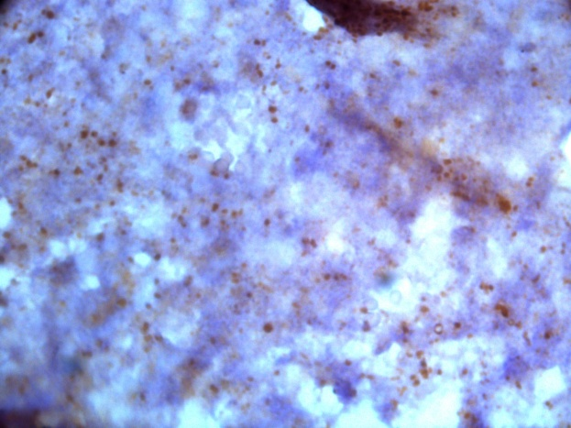 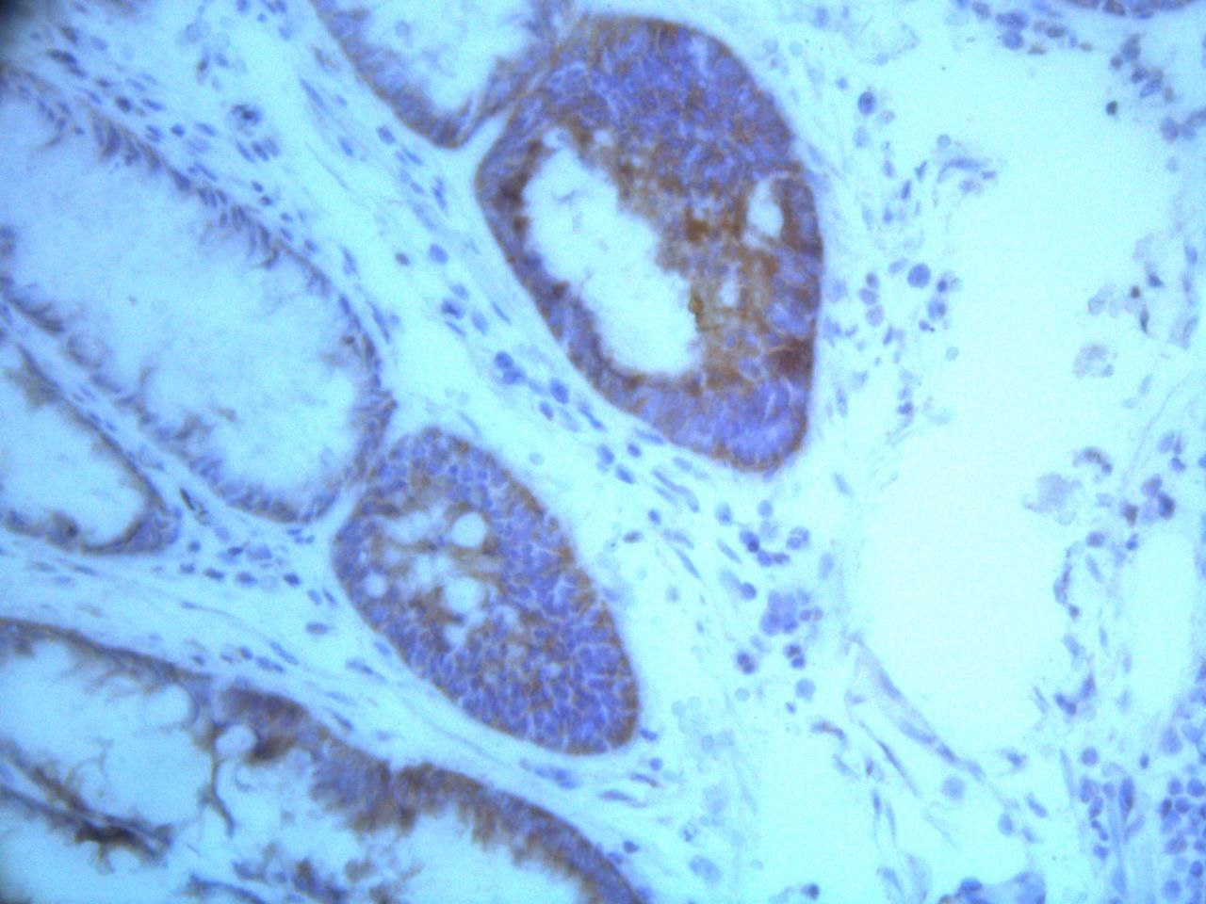

**Figure (4): Detection of H.pylori under microscope by IHC techniques.**

The histopathological findings revealed adenocarcinoma as the most prevalent histological type (27.5%), consistent with global epidemiological trends where colorectal adenocarcinoma dominates gastrointestinal malignancies [19]. This aligns with Brenner et al. (2014), who reported adenocarcinoma as the primary histological subtype in 60–70% of colorectal cancers, though the lower prevalence in this cohort may reflect regional variations or early-stage disease [19]. The coexistence of ulcerative colitis (UC) and adenomatous polyps in 12.5% of cases supports the established "inflammation-dysplasia-carcinoma" sequence, as described by Itzkowitz and Yio (2004), wherein chronic inflammation accelerates polyp malignant transformation [20, 21]. Juvenile polyps, observed in 10% of patients, are less commonly associated with malignancy, but their presence underscores the need for vigilant surveillance in younger populations, as highlighted by Jass et al. (2002) [22].

The detection of *Helicobacter pylori* (*H. pylori*) via immunohistochemistry (IHC, 57.5%) outperformed serological testing (47.5%), mirroring prior studies advocating tissue-based methods for accuracy. Graham and Miftahussurur (2018) emphasized that IHC’s direct visualization of bacteria in biopsy specimens reduces false negatives caused by patchy colonization or prior antibiotic use [23]. Conversely, the low sensitivity (34.78%) and specificity (35.29%) of serum testing align with Kato et al. (2013), who attributed such limitations to cross-reactive antibodies or transient infections unrelated to active disease [24]. These findings reinforce IHC as the gold standard for diagnosing active *H. pylori* infections in clinical practice.

Notably, serum *H. pylori* positivity showed a significant association with adenocarcinoma (p=0.015), suggesting systemic immune activation or bacterial virulence factors (e.g., CagA) may contribute to carcinogenesis. Polk and Peek (2010) proposed that systemic *H. pylori* antigens could induce chronic inflammation and DNA damage, promoting oncogenic pathways[25]. However, the lack of significant tissue-specific IHC detection (p=0.363) contrasts with Uemura et al. (2001), who reported strong correlations between gastric *H. pylori* colonization and adenocarcinoma[26].This discrepancy may reflect organ-specific pathogenicity or differences in bacterial load, warranting further investigation into systemic versus localized *H. pylori* effects.

The study’s small sample size (n=40) limits statistical power, particularly in subgroup analyses (e.g., juvenile polyps, n=4). Larger cohorts, such as those in the SEER database studies, are essential to validate these trends [27]. Future research should integrate molecular techniques (e.g., PCR, metagenomics) to elucidate strain-specific virulence and host-microbe interactions in carcinogenesis.

**4- CONCLUSION**

This study highlights the predominance of adenocarcinoma in colorectal pathologies and reinforces immunohistochemistry as the gold standard for detecting active H. pylori infections. The significant association between systemic H. pylori seropositivity and adenocarcinoma underscores the potential role of bacterial virulence factors or systemic inflammation in carcinogenesis, contrasting with nonspecific tissue colonization observed via IHC. Limitations, including a small sample size and single-center design, necessitate cautious interpretation. Future research should prioritize multicenter cohorts, molecular analyses of H. pylori strains, and exploration of host-pathogen interactions to elucidate mechanisms linking H. pylori to colorectal cancer. These efforts could refine diagnostic protocols and therapeutic strategies for high-risk populations.

Recommendations: Future research should prioritize larger, multicenter cohorts to validate the association between systemic H. pylori seropositivity and colorectal adenocarcinoma, integrating molecular techniques (e.g., PCR, metagenomics) to enhance diagnostic accuracy and explore strain-specific virulence mechanisms. Mechanistic studies are needed to elucidate H. pylori’s role in carcinogenesis, focusing on systemic inflammation and host-pathogen interactions, while clinical protocols should prioritize immunohistochemistry (IHC) for active infection diagnosis and incorporate systemic H. pylori status as a biomarker for risk assessment. Public health efforts should target smoking cessation and provider education on updated diagnostic guidelines, alongside funding initiatives to support interdisciplinary collaborations, particularly in high-prevalence regions, to advance understanding and improve patient outcomes.

**5. Source of Funding:**

The current study was funded by our charges with no any other funding sources elsewhere.

**6. Ethical Clearance:**

Official approval has been obtained samples from patients and data were analyzed without the names to protect privacy. This study was conducted according to the approval of College of Medicine/ University of Anbar and in accordance with the ethical guidelines of the Declaration of ethical committee of the College (Ref: 58, Date: 17/4/2024).Provide a statement that what is expected, as stated in the "INTRODUCTION" section can ultimately result in "RESULTS AND DISCUSSION" section, so there is compatibility. Moreover, it can also be added the prospect of the development of research results and application prospects of further studies into the next (based on result and discussion).

**REFERENCES**

1. Hooi, J. K. Y., Lai, W. Y., Ng, W. K., Suen, M. M. Y., Underwood, F. E., Tanyingoh, D., ... & Ford, A. C. (2017). Global prevalence of Helicobacter pylori infection: Systematic review and meta-analysis. Gastroenterology, 153(2), 420–429. <https://doi.org/10.1053/j.gastro.2017.04.022>
2. Cover, T. L., & Blaser, M. J. (2009). Helicobacter pylori in health and disease. Gastroenterology, 136(6), 1863–1873. <https://doi.org/10.1053/j.gastro.2009.01.073>
3. de Bernard, M., & Josenhans, C. (2014). Pathogenesis of Helicobacter pylori infection. Helicobacter, 19(Suppl 1), 11–18. <https://doi.org/10.1111/hel.12160>
4. Hatakeyama, M. (2004). Oncogenic mechanisms of the Helicobacter pylori CagA protein. Nature Reviews Cancer, 4(9), 688–694. <https://doi.org/10.1038/nrc1433>
5. Elbehiry, A., Marzouk, E., Hamada, M., Moussa, I. M. I., El-Gedawy, A., & Yang, J. (2023). Helicobacter pylori infection: Current status and future prospects on diagnostic, therapeutic and control challenges. Antibiotics, 12(2), 191. <https://doi.org/10.3390/antibiotics12020191>
6. Sung, H., Ferlay, J., Siegel, R. L., Laversanne, M., Soerjomataram, I., Jemal, A., & Bray, F. (2021). Global cancer statistics 2020: GLOBOCAN estimates of incidence and mortality worldwide for 36 cancers in 185 countries. CA: A Cancer Journal for Clinicians, 71(3), 209–249. <https://doi.org/10.3322/caac.21660>
7. Butt, J., & Epplein, M. (2019). Helicobacter pylori and colorectal cancer—A bacterium going abroad? PLoS Pathogens, 15(8), e1007861. <https://doi.org/10.1371/journal.ppat.1007861>
8. Hossain, M. S., Karuniawati, H., Jairoun, A. A., Abu-Naser, S. M., Alrashdi, I., & Ganesan, V. B. (2022). Colorectal cancer: A review of carcinogenesis, global epidemiology, current challenges, risk factors, preventive and treatment strategies. Cancers, 14(7), 1732. <https://doi.org/10.3390/cancers14071732>
9. Testa, U., Pelosi, E., & Castelli, G. (2018). Colorectal cancer: Genetic abnormalities, tumor progression, tumor heterogeneity, clonal evolution and tumor-initiating cells. Medical Sciences, 6(2), 31. <https://doi.org/10.3390/medsci6020031>
10. Vogelstein, B., Fearon, E. R., Hamilton, S. R., Kern, S. E., Preisinger, A. C., Leppert, M., ... & White, R. (1988). Genetic alterations during colorectal-tumor development. The New England Journal of Medicine, 319(9), 525–532. <https://doi.org/10.1056/NEJM198809013190901>
11. Hanahan, D., & Weinberg, R. A. (2011). Hallmarks of cancer: The next generation. Cell, 144(5), 646–674. <https://doi.org/10.1016/j.cell.2011.02.013>
12. Wood, L. D., Parsons, D. W., Jones, S., Lin, J., Sjoblom, T., Leary, R. J., ... & Vogelstein, B. (2007). The genomic landscapes of human breast and colorectal cancers. Science, 318(5853), 1108–1113. <https://doi.org/10.1126/science.1145720>
13. Li, Q., Liu, Q., Ma, J., Dai, W., Mo, S., Xu, Y., ... & Cai, G. (2024). Signaling pathways involved in colorectal cancer: Pathogenesis and targeted therapy. Signal Transduction and Targeted Therapy, 9, 266. <https://doi.org/10.1038/s41392-024-01953-7>
14. Abdul-Lateef, W. T., Abdullah, E. M., & Ghadhban, J. M. (2021). Study the role of Helicobacter pylori infection in a group of Iraqi patients with colorectal cancer. Indian Journal of Forensic Medicine & Toxicology, 15(1), 2396–2402. <https://doi.org/10.37506/ijfmt.v15i1.13760>
15. Khashman, B. M., Karim, S. K., Alhilli, H. M., & Ali, M. J. (2020). Possible role of HCMV infection on the development of HPV positive cervical carcinoma in a group of Iraqi women. Biochemical and Cellular Archives, 20(1), 1549–1552. <https://doi.org/10.35124/bca.2020.20.1.1549>
16. Arnold, M., Sierra, M. S., Laversanne, M., Soerjomataram, I., Jemal, A., & Bray, F. (2017). Global patterns and trends in colorectal cancer incidence and mortality. Gut, 66(4), 683–691. <https://doi.org/10.1136/gutjnl-2015-310912>
17. Ladeiras-Lopes, R., Pereira, A. K., Nogueira, A., Pinheiro-Torres, T., Pinto, I., Santos-Pereira, R., & Lunet, N. (2008). Smoking and gastric cancer: Systematic review and meta-analysis of cohort studies. Cancer Causes & Control, 19(7), 689–701. <https://doi.org/10.1007/s10552-008-9132-y>
18. Kuipers, E. J., Grady, W. M., Lieberman, D., Seufferlein, T., Sung, J. J., Boelens, P. G., ... & Watanabe, T. (2015). Colorectal cancer. Nature Reviews Disease Primers, 1, 15065. <https://doi.org/10.1038/nrdp.2015.65>
19. Brenner, H., Kloor, M., & Pox, C. P. (2014). Colorectal cancer. The Lancet, 383(9927), 1490–1502. <https://doi.org/10.1016/S0140-6736(13)61649-9>
20. Chen, Y., & Blaser, M. J. (2012). Association between gastric Helicobacter pylori colonization and glycated hemoglobin levels. Journal of Infectious Diseases, 205(8), 1195–1202. <https://doi.org/10.1093/infdis/jis106>
21. Itzkowitz, S. H., & Yio, X. (2004). Inflammation and cancer IV. Colorectal cancer in inflammatory bowel disease: The role of inflammation. American Journal of Physiology-Gastrointestinal and Liver Physiology, 287(1), G7–G17. <https://doi.org/10.1152/ajpgi.00079.2004>
22. Jass, J. R., Whitehall, V. L. J., Young, J., & Leggett, B. A. (2002). Emerging concepts in colorectal neoplasia. Gastroenterology, 123(3), 862–876. <https://doi.org/10.1053/gast.2002.35392>
23. Graham, D. Y., & Miftahussurur, M. (2018). Helicobacter pylori urease for diagnosis of Helicobacter pylori infection: A mini review. Journal of Advanced Research, 13, 51–57. <https://doi.org/10.1016/j.jare.2018.01.006>
24. Demiray, E., Yilmaz, O., Sarkis, C., Soyturk, M., & Simsek, I. (2006). Comparison of invasive methods and two different stool antigen tests for diagnosis of H. pylori infection in patients with gastric bleeding. World Journal of Gastroenterology, 12(26), 4206–4210. <https://doi.org/10.3748/wjg.v12.i26.4206>
25. Polk, D. B., & Peek, R. M. J. (2010). Helicobacter pylori: Gastric cancer and beyond. Nature Reviews Cancer, 10(6), 403–414. <https://doi.org/10.1038/nrc2857>
26. Uemura, N., Okamoto, S., Yamamoto, S., Matsumura, N., Yamaguchi, S., Yamakido, M., ... & Taniyama, K. (2001). Helicobacter pylori infection and the development of gastric cancer. The New England Journal of Medicine, 345(11), 784–789. <https://doi.org/10.1056/NEJMoa001999>
27. Noone, A. M., Howlader, N., Krapcho, M., et al. (2018). SEER Cancer Statistics Review, 1975–2017. National Cancer Institute. Based on the November 2017 SEER data submission. <https://seer.cancer.gov/csr/1975_2017/>

**التأثير المحتمل لعدوى الجرثومة الملوية البوابية على تطور سرطان القولون والمستقيم.**

**الـخـلاصـة**

بحثت هذه الدراسة المقطعية العلاقة بين عدوى الملوية البوابية (H. Pylori) والأنواع الفرعية النسيجية المرضية لآفات القولون والمستقيم لدى 40 مريضًا يعانون من الأعراض. واستُخدمت طرق الفحص المصلي (ELISA) والفحص المناعي النسيجي الكيميائي (IHC) للكشف عن جرثومة الملوية البوابية. وأظهرت المجموعة غلبة الذكور (77,5%) بمتوسط أعمار 50,45 ± 17,27 عامًا. وكان سرطان الغدة الدرقية هو النوع الفرعي النسيجي المرضي الأكثر شيوعًا (27,5%)، يليه التهاب القولون التقرحي المصحوب بأورام غدية حميدة (12,5%). وقد كشف الفحص المناعي النسيجي الكيميائي عن الملوية البوابية لدى 57,5% من المرضى، متفوقًا على الفحص المصلي (47,5%)، والذي أظهر حساسية منخفضة (34,78%) وخصوصية منخفضة (35,29%).

ارتبطت إيجابية مصل البكتيريا الملوية البوابية ارتباطًا وثيقًا بسرطان الغدد (p=0.015)، مما يشير إلى تورط جهازي في التسرطن، بينما لم يُظهر اختبار IHC أي ارتباط خاص بالأنسجة (p=0.363)، ولكنه يشير إلى تورط مباشر للبكتيريا في تطور سرطان القولون والمستقيم. تؤكد هذه النتائج تفوق اختبار IHC في التشخيص، وتقترح أن تكون حالة البكتيريا الملوية البوابية الجهازية مؤشرًا حيويًا محتملًا لخطر الإصابة بسرطان الغدد. يتطلب الأمر إجراء دراسات أوسع للتحقق من صحة هذه الملاحظات.