**Physiological and Immunological Variations between Alfa and Beta Male Thalassemia in Baghdad.**

**Maliah H. Hamel1*, Asmaa H. juma1 and Mousa M. Marbut2**

1Department of Biology, University of Samarra-College of Education, Samarra, Iraq

2Department of computer engineering techniques, University of Dijlah, Baghdad, Iraq

|  |  |  |
| --- | --- | --- |
| **Article Info** |  | **ABSTRACT** |
| ***Article history:***  Received April, 14, 2025  Revised May, 29, 2025  Accepted June, 30, 2025 |  | Βeta thalassemia, which is characterized by impaired beta globin chain synthesis. β-thalassemia major, A severe anemia with ineffective red blood cell production that can be life-threatening. Interleukin-6 had been reported to elevate in βeta Thalassemia patients and this may be due to multiple Hemotransfusion. This study aims to investigate the roles of blood ferritin, **IL-6 & IFN-** **γ** in Beta Thalassemia Major individuals as compare with α-thalassemia patients. Patients and methods; Eighty male subjects were participated in the present study, (20 male patients with Beta thalassemia, 20 male patients with alfa thalassemia and 40 male normal healthy subjects. The work was done in Al-baldy hospital in Baghdad from beginning of December 26, 2023 to the end of April 2024. Blood samples were taken from all patients. Hematological, IL-6 and IFN- γ were measured.  There is a highly significant increase in ferritin levels of β-thalassemia patients as compare with α-thalassemia cases. Also, a substantial increase is observed (p≤0.01) in the IL-6 level of β-thalassaemia major patients, as compared with α thalassemia patients. |
| ***Keywords:***  Thalassemia,  Beta,  Ferritin,  IL-6,  IFN- γ |
|  |
| ***Corresponding Author:***  * Maliah H. Hamel Department of Biology, University of Samarra-College of Education, Samarra, Iraq  AL Mahdya street, Baghdad, Iraq  Email: [maliahhatem58@gmail.com](mailto:maliahhatem58@gmail.com) | | |

**1- INTRODUCTION**

The major important forms of thalassaemia result from an autosomal mutant gene that reduces the rate of synthesis of α- and β-polypeptide chains of HbA [1, 2].

Β-Thalassemia, which is characterized by impaired beta globin chain synthesis. Β-thalassemia major, It is a severe and potentially fatal anemia marked by ineffective red blood cell production [3].

The treatment of β-thalassemia patients encompasses various aspects, including blood transfusions. However, these transfusions result in iron overload, creating a vicious cycle, It is a severe and potentially fatal anemia characterized by ineffective red blood cell production, particularly affecting organs that gather excess iron, such as the liver, pituitary gland, pancreas, and heart [4].

Patients with viral hepatitis (B virus and/or C virus) exhibited a notable reduction in white blood cells count compared to those without contamination. Additionally, virally infected β-thalassemia patients exhibited significantly higher values compared to those without infections [5].

Interleukin-6 had been found an increase in βeta Thalassemia patients and this may be due to several blood transfusions [6, 7, 8].

Interferon-gamma (IFN-γ) is a type of cytokine. That promotes inflammation by activating immune cells and improving antigen presentation [9, 10, 11].

IFN-γ is secreted by natural killer cells during the innate immune response, as well as by CD4+ Th1 cells and CD8+ cytotoxic T lymphocytes (CTLs) upon activation of the adaptive immune system [12, 13].

The objective of the study is examine the functions of IL-6 and IFN-¥ in Beta Thalassemia Major Individual as compare with α-thalassemia patients.

**2- METHODS AND STATISTICAL EVALUATION**

Eighty male subjects were participated in the present study, (20 male patients with Beta thalassemia, 20 male patients with alfa thalassemia and 40 male normal healthy subjects. The work was done in Al-baldy hospital in Baghdad from beginning of December 26, 2023 to the end of April 2024.

All subjects were aged between (8-18) years. Blood was drawn through antecubital vein puncture between 8.00 am and 11.00 am. Serum isolated from blood, and then was frozen at −20 °C until measurements.

Height and weight were recorded, and the body mass index (BMI) was determined by dividing the weight (in kilograms) by the height (m2) formula [14].

Body weight and height were measured. Blood parameters (PCV, hemoglobin and WBCs) were measured according standard procedures.

VIDAS instruments were used to measure Serum human ferritin was assessed using the ELFA (Enzyme-Linked Fluorescent Assay) technique. Ferritin levels in the serum were determined with the VIDAS ferritin kit (Biomerieux - 69280).

IL-6 was measured by kit Enzyme-linked immunoassay (ELISA) is currently the test of choice. IL-6 levels for all samples were measured Using the Human IL-6/Interleukin-6 ELISA Kit from Boster Antibody & ELISA Experts, USA.

All data are indicated as the mean ± standard deviation. The means of the measured variables the data were analyzed using an unpaired Student’s t-test, with a p-value of less than 0.05 regarded as statistically significant.

**3- RESULT AND DISCUSSION**

The present study showed that the body weight and body mass index in older patients was significantly decreased as compared with the control. The present result agrees with previous finding, especially in patients with regular transfusion [3]. Previous studies found that a relationship between regular blood transfusion and reduction in body growth in thalassemia patients, [4, 5, 14].

**Table (1)** Display the age, body weight, and body mass index of male beta thalassemia patients and male α thalassemia patients.

|  |  |  |  |
| --- | --- | --- | --- |
| Parameters | β Thalassemia patients | α thalassemia) | P-value |
| Age (years) | 13.14 ± 3.6 | 15.1 ± 1.3 | NS |
| Body Weight (Kg) | 31.7 ± 6.9 | 39.5 ± 7.3 | 0.01 |
| BMI (kg/M2) | 15.4 ± 3.8 | 17.7 ± 2.3 | 0.01 |

**Table 2** shows the comparison of Hb, Packed Cell Volume, (pcv), and Wight blood cells between men **β** thalassemia cases and men **α** thalassemia.

The present study found a marked reduction in hemoglobin concentration and packed cell volume, (PCV) of male beta thalassemia patients (**7.5 ± 0.2** gm/dl) as compare with α- male thalassemia patients, (9.7 ± 2.1 gm/dl). The present finding agrees with previous results [2, 5].

**Table (2)** the mean and SD of Hb, PCV and Wight blood cells of men **βThalassemia** cases and men **α thalassemi**a.

|  |  |  |  |
| --- | --- | --- | --- |
| Parameters | β Thalassemia patients | α thalassemia) | P≤ value |
| Hemoglobin (g/dl) | 7.0 ± 0.2 | 9.7 ± 2.1 | 0.01 |
| PCV (L/L) | 28.4 ± 5.1 | 36.3 ± 5.8 | 0.01 |
| WBC 103 /ml | 7.6 ± 3.4 | 8.14 ± 1.5 | NS |

**NS= No significant**

**Table 2** show a high significant reduction in PCV, of beta thalassemia patients as compare with male **α** thalassemia, (P ≤ 0.01). This result agrees with previous studies [2, 5].

However, in this study, there is unsignificant difference in the total count of white blood cells count of βeta thalassemia patients as compare with α thalassemia patient. The present study does not agree with previous studies, who found a significant elevation in WBCs of thalassemia patients [5, 15, 16].

In **table 3**, there is a highly notable rise in ferritin levels. concentration of β-thalassemia patients (4417 ± 117.4 ng/ml) as compare with α-thalassemia patients (367.1 ± 86.1ng/ml; P≤ 0.01), as shown in table 3. The present result of ferritin agrees with previous findings [4, 14].

Table 3 show the mean and Standard Deviation of ferritin and IL-6 of thalassemia patients and control subjects

|  |  |  |  |
| --- | --- | --- | --- |
| Parameters | β Thalassemia patients | α thalassemia) | P≤ value |
| Ferritin (ng/ml) | 4417 ± 117.4 | 367.1 ± 86.1 | 0.01 |
| IL-6 | 367.4 ± 86 | 115.8 ± 50.3 | 0.01 |
| IFN- γ | 342 ± 153 | 219.4 ± 26.9 | 0.05 |

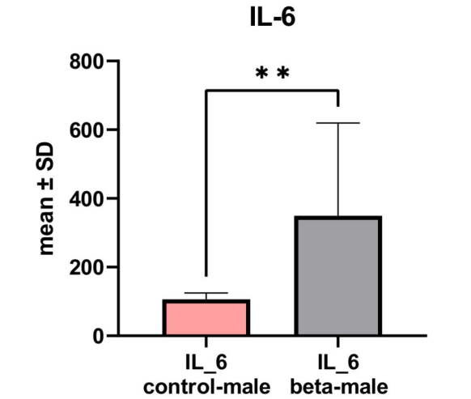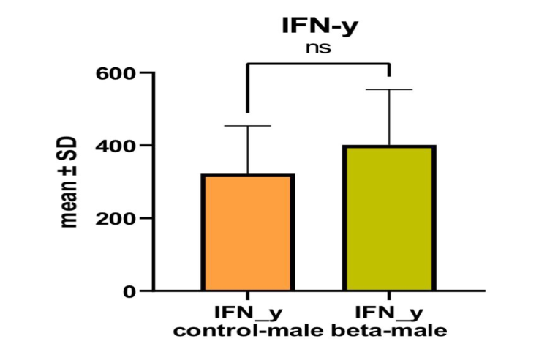

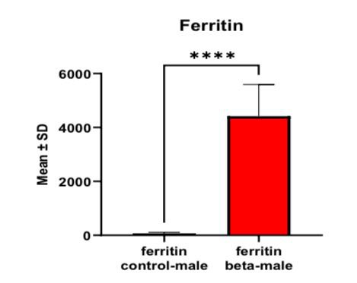

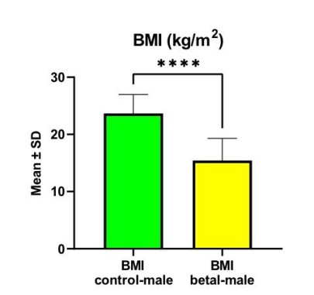

Also, **table 3** show that there is a highly remarkable elevation (p≤0.01) in the IL-6 level of β-thalassaemia major patients, (**367.4 ± 86** pg/mol) as compared with α thalassemia patients, (**115.8 ± 50.3**).

Previous studies found that the elevation in concentrations of IL-6 concentration in β-thalassemia is due to several hemotransfusion and other complications, such as splenectomy and increased ferritin levels, which [17, 18, 19, 20].

Also, **table 3** show that there is a noteworthy rise (p≤0.05) in the **IFN-** **γ** amount of beta thalassaemic patients, (**342 ± 153** pg/ml) as compared with alfa thalassemia patients (**219.4 ± 26.9**).

Patients with β-thalassemia are more likely to experience unfavorable effects on hematopoiesis due to elevated cytokine levels, (21). A connection between the physiological production of particular cytokines and their genotype [22, 23, 24].

**4- CONCLUSION**

The present study concludes that a significant rise in serum ferritin, IL-6 and IFN-γ in βeta thalassemia patients as compare with α thalassemia patients.

The present study recommends the determination of other cytokines which related to immune system of thalassemia patients such as IL=17 and IL-40.

**REFERENCES**

1. Rund, D., & Rachmilewitz, E. (2001). Pathophysiology of alpha and beta thalassemia. Seminars in Hematology, 38(4), 343–349.
2. Riaz, H., Riaz, T., Khan, M. U., Aziz, S., et al. (2011). Serum ferritin levels, sociodemographic factors and desferrioxamine therapy in multi-transfused thalassemia major patients at a government tertiary care hospital of Karachi, Pakistan. BMC Research Notes, 4, 287–292.
3. Younus, Z. M., Alhially, Y. A. H., & Dallal Bashi, A. Y. (2012). Evaluation of conventional renal function tests in β-thalassemia major patients in Nineveh province. Tikrit Journal of Pharmaceutical Sciences, 8(1), 6–14.
4. Baker, A. S., Marbut, M. M., & Al-Ani, A. H. (2019). Study the relationship between liver functions and IL-10 in female thalassemia patients in Kirkuk city. Tikrit Journal of Pure Sciences, 24(2), 1–4. <https://doi.org/10.25130/tips.24.2019.021>
5. Ayyash, H., & Sirdah, M. (2018). Hematological and biochemical evaluation of β-thalassemia major (βTM) patients in Gaza Strip: A cross-sectional study. International Journal of Health Sciences, 12(6), 18–24.
6. Arbab, G. O. L. N. A. Z., Sobhani, A., Kordi, M. R., & Gaeini, A. A. (2018). Effect of concurrent training on inflammatory markers of Beta Thalassemia Major patients. Horizon Medical Journal, 22(1), 1–11. <https://doi.org/10.29252/hmj.22.1.1>
7. Deeb, M. M., Dawoud, A. A., El-Hawy, M. A., Wasel, Y. F., & El Sayed, A. E. (2019). Study of adipocytokines (visfatin and resistin) levels in children with β-thalassemia major and intermedia. Menoufia Medical Journal, 32(3), 1051.
8. Harbi, N. S., Jawad, A. H., & Alsalman, F. K. (2020). Evaluation of adipokines concentration in Iraqi patients with major and minor beta-thalassemia. Reports of Biochemistry & Molecular Biology, 9(2), 209–215. <https://doi.org/10.29252/rbmb.9.2.209>
9. Ghanem, S. E., Abdel-Samiee, M., Torky, M. H., et al. (2020). Role of resistin, IL-6 and NH2-terminal portion proBNP in the pathogenesis of cardiac disease in type 2 diabetes mellitus. BMJ Open Diabetes Research and Care, 8(1), e001206. <https://doi.org/10.1136/bmjdrc-2020-001206>
10. Merli, P., Quintarelli, C., Strocchio, L., & Locatelli, F. (2021). The role of interferon-gamma and its signaling pathway in pediatric hematological disorders. Pediatric Blood & Cancer, 68, e28900. <https://doi.org/10.1002/pbc.28900>
11. Morales-Mantilla, D. E., & King, K. Y. (2018). The role of interferon-gamma in hematopoietic stem cell development, homeostasis, and disease. Current Stem Cell Reports, 4(3), 264–271.
12. Groom, J. R., & Luster, A. D. (2011). CXCR3 ligands: Redundant, collaborative and antagonistic functions. Immunology & Cell Biology, 89(2), 207–215.
13. de Bruin, A. M., Voermans, C., & Nolte, M. A. (2014). Impact of interferon-gamma on hematopoiesis. Blood, 124(16), 2479–2486.
14. Yousefian, S., Aliabad, G. M., Saleh, R., & Khedmati, M. (2022). Association of body mass index and serum ferritin level in pediatrics with beta-thalassemia major disease. Iranian Journal of Pediatric Hematology & Oncology, 12(1).
15. Horowitz, J., Leonard, D., Smith, J., & Brotman, S. (1992). Postsplenectomy leukocytosis: Physiologic or an indicator of infection? The American Surgeon, 58, 387–390. <https://doi.org/10.24875/ciru.21000246>
16. Khawaji, M. M., Hazzazi, A. A., Ageeli, M. H., et al. (2020). Clinical and hematological features among β-thalassemia major patients in Jazan region: A hospital-based study. Journal of Family Medicine and Primary Care, 9, 412–417. <https://doi.org/10.4103/jfmpc.jfmpc_1007_19>
17. Roshdy, M. N., Harfoush, R. A., Hamed, N. A., & Morsi, M. G. (2013). Quantitative estimation of interferon-gamma levels among Egyptian polytransfused haematology cases. Eastern Mediterranean Health Journal, 19(5), 490–494.
18. Consolini, R., et al. (2001). Immunological evaluation of patients with beta-thalassemia major. Acta Haematologica, 105, 7–12.
19. El-Beshlawy, A., & Youssry, I. (2009). Prevention of hemoglobinopathies in Egypt. Hemoglobin, 33(Suppl. 1), S14–S20.
20. Gluba-Brzózka, A., Franczyk, B., & Rysz-Górzyńska, M. (2021). Pathomechanisms of immunological disturbances in thalassemia. International Journal of Molecular Sciences, 22, 9677–9689. <https://doi.org/10.3390/ijms22189677>
21. Al-Hakeim, H. K., Najm, A. H., Al-Dujaili, A. H., & Maes, M. (2020). Major depression in children with transfusion-dependent thalassemia is strongly associated with the combined effects of blood transfusion rate, iron overload, and increased pro-inflammatory cytokines. Neurotoxicity Research, 38(1), 228–241.
22. Naji, B. A. A. (2024). The association between cytokines (IFN-γ and IL-4) gene polymorphisms and clinical manifestations of β-thalassemia in Iraqi patients. Naturalista Campano, 28(1), 1573–1578.
23. Abd-AlKareem Abd, D., Lafta, F. M., & Alwan, Y. F. (2022). The association between plasma IL-6 levels and several thalassemia-related clinical features in Iraqi patients. International Journal of Health Sciences, 6(S6), 548–561. <https://doi.org/10.53730/ijhs.v6nS6.10343>
24. Aneed, N. S., Fadhil, R. K., & Kadhum, S. M. (2024). Immunological assessment of interleukin-6 and 8 in Baghdad patients with β-thalassemia. South Eastern European Journal of Public Health, 10, 187–194. <https://doi.org/10.70135/seejph.vi.1659>

**الإختلافات الفسيولوجية والمناعية بين الثلاسيميا ألفا وبيتا في بغداد**

**الـخـلاصـة**

تتميز الثلاسيميا بيتا بضعف تخليق سلسلة بيتا غلوبين.تتصف بيتا ثلاسيميا الكبرى، بفقر دم حاد يصاحبه ضعف في إنتاج خلايا الدم الحمر, وقد يُهدد حياه المريض. أُبلغ عن ارتفاع مستوى إنترلوكين-6 لدى مرضى ثلاسيميا بيتا، وقد يُعزى ذلك إلى عمليات نقل الدم المتكررة.

تهدف هذه الدراسة إلى دراسة دورناقل الحديد الفيريتين في الدم، والإنترلوكين-6، والإنترفيرون- جاما لدى مرضى ثلاسيميا بيتا الكبرى، مقارنةً بمرضى ثلاسيميا ألفا.

شارك في الدراسة الحالية ثمانون ذكرًا (20 مريضًا مصابًا بثلاسيمية بيتا و20 مريضًا مصابًا بثلاسيمية ألفا و40 ذكرًا سليمًا. تم إجراء العمل في مستشفى البلدي في بغداد من بداية 26 ديسمبر 2023 إلى نهاية أبريل 2024. تم أخذ عينات الدم من جميع المرضى. تم قياس الدم وIL-6 وIFN-γ.

نستنتج من هذا البحث أن هناك زيادة كبيرة للغاية في مستويات الفيريتين لدى مرضى بيتا ثلاسيميا مقارنة بحالات ألفا ثلاسيميا. كما لوحظت زيادة كبيرة (p < 0.01) في مستوى IL-6 لدى مرضى بيتا ثلاسيميا الكبرى، مقارنة بمرضى ثلاسيميا الفا.