**Prevalence of Salmonella Bacteria Causing Intestinal Diarrhea in Domestic Dogs and Cats and Identification of Their Genetic Diversity in Diwaniyah Governorate, Iraq**

**Mohammad Hassan Mazhar\***

Al-Qadisiyah Education Directorate, Al-Qadisiyah, Iraq

|  |  |  |
| --- | --- | --- |
| **Article Info** |  | **ABSTRACT** |
| ***Article history:***  Received April, 14, 2025  Revised May, 25, 2025  Accepted June, 29, 2025 |  | The study aimed to investigate the prevalence of Salmonella bacteria in dogs and cats infected with diarrhea for the period (from October 2024 to March 2025), where 40 samples were collected and divided into two groups (20 dog samples) and (20 cat samples). Salmonella bacteria were isolated and diagnosed using phenotypic, biochemical and molecular methods. The number of confirmed positive isolates was 10 isolates, representing 40%, distributed as follows: 7 dogs and 3 cats. The incidence of several virulence genes invA and SiTc was also evaluated for all culture-positive Salmonella isolates. The SiTc gene was 30% prevalent (3: 2 dogs and 1 cat), but the invA gene was 100% prevalent, making it an effective PCR diagnostic tool for Salmonella. The genetic diversity of the bacteria under study was also identified using RAPD technology. PCR results showed that there was genetic variation among the ten diagnosed isolates, and they were distributed in three clusters (I,V,IV) with a total of 4 variations. In conclusion, it must be noted that dogs, especially domestic ones, act as a reservoir for invasive Salmonella bacteria, so society needs strict health measures to prevent its spread to humans. |
| ***Keywords:***  Salmonella Bacteria,  Infectious Diseases,  Animal Health,  Genetic Diversity of Salmonella |
|  |
| ***Corresponding Author:***  * Mohammad Hassan Mazhar  Al-Qadisiyah Education Directorate, Al-Qadisiyah , Iraq  Email: [husssaindaik@gmail.com](mailto:husssaindaik@gmail.com) | | |

**1- INTRODUCTION**

Salmonella bacteria are a major cause of intestinal diarrhea in dogs and cats, significantly impacting the health of these pets. These bacteria are found in the intestines of many animals, including dogs and cats, and are excreted in their feces, increasing the risk of transmission to other animals or even humans through food or contaminated water. Salmonella is also found in a variety of animals, including reptiles and birds, and can be transmitted to dogs and cats through the consumption of contaminated food or through direct contact with infected animals. Common symptoms of infection include diarrhea, fever, and stomach cramps, and in some cases, infection can lead to serious complications such as dehydration. All Salmonella strains contain the SPI-1 Island, which provides the ability to cause disease [1].

The invasion gene (invA, which encodes a type 3 secretion system protein, is one of the pathogenic plasmids carried by SPI-1., and the Salmonella iron transporter C gene (sitC), one of the genes encoding iron acquisition, are among other virulent genes found in the Salmonella serotype. [2] Determining the genetic diversity of Salmonella bacteria is vital to understanding how they spread and how to control them. Recent studies indicate that genetic diversity can affect the severity of infection and the response of animals to treatment, making continued research in this area necessary. An important source of environmental contamination from Salmonella is the release of the pathogen in the feces of healthy carrier animals. Due to their proximity to other animals and their owners, Salmonella with dangerous resistance genes are excreted in the feces of animals with clinical diseases such as diarrhea caused by immunosuppression without diarrhea [3, 4].

The implications of genetic diversity among Salmonella isolates for treatment and prevention strategies in veterinary medicine include several aspects, including understanding antibiotic resistance and vaccine development. Different isolates also exhibit different symptoms or respond differently to treatments. Therefore, advanced diagnostic techniques are required to accurately identify isolates.

**2- MATERIALS AND METHODS**

**2.1. Sample Collection**

Between May 2023 and August 2024, 40 rectal samples were taken from dogs of various breeds that had diarrhea and were between the ages of two months and five years. The Diwaniyah Governorate's several regions were the sites of the study. In the lab, the samples were gathered and refrigerated in sterile plastic containers.

**2.2. Identification of isolates:**

For 24 hours, swabs were incubated aerobically at 37°C after being pre-enriched with buffered peptone water. A loopful of BPW culture was inoculated into Rapapport-Vasiliadis broth, then tetrathionate broth, and incubated at 42°C for 18 hours to enrich the culture. After 24 hours at 37°C, the tetrathionate broth culture was re-sprouted onto xylose-lysine agar (XLD agar). Subcultures of typical presumptive Salmonella colonies were made from each sample and incubated at 37°C for 24 hours on MacConkey agar (MCA). Biochemical tests (urease and triple sugar iron agar tests) and serotype determination of somatic (O) and capsular (Vi) antigens using Salmonella O poly A-I antiserum were performed following standard procedures to identify samples as Salmonella.

**2.3. Polymerase chain reaction (PCR) testing for virulence gene detection**

Using the Promega DNA Bacterial Extraction Kit, according to the manufacturer's US instructions, Salmonella-associated DNA was extracted from the selected samples. Using the specific primers listed in Table 2.1, it was possible to test for the presence of the three virulence genes invA and sitC. Each PCR reaction contained positive controls from the kit, while negative controls used sterile distilled water. 1.5% agarose was used to analyze the PCR products under ultraviolet (UV) light.

**Table (2) nucleotide sequences of the primers utilized in the investigation, as well as the amplification product's size**

|  |  |  |  |  |
| --- | --- | --- | --- | --- |
| **Gene name** | **Oligo sequence (5'-3') (primer)** | | | **Product**  **Size( bp)** |
| ***Inv A*** | **F** | **CTGGCGGTGGGTTTTGTTGTCTTCTATT** | **502** | | |
| **R** | **AGTTTCTCCCCCTCTTCATGCGTTACCC** |
| ***Sit c*** | **F** | **CAGTATATGCTCAACGCGATGTGGGTCTCC** | **290** | | |
| **R** | **CGGGGCGAAAATAAAGGCTGTGATGAAC** |
| **Eric 1**  **Eric 2** | **ATGTAAGCTCCTGGGGATTCAC** | | **1000-250** | | |
| **AAGTAAGTGACTGGGGTGAGC** | |

**3- RESULTS AND DISCUSSION**

This study revealed the prevalence of some genes responsible for the pathogenesis of Salmonella enterica, particularly InvA and sitC. These genes encode a type 3 secretion system protein in the inner membrane that helps bacteria invade host epithelial cells [5, 6].

It is noteworthy that 10 (40%) of the 40 cultured rectal swabs showed positive Salmonella growth. All 10 (100%) of the Salmonella isolated tested positive for type A PCR (Figure 1). One (10%) of the isolates tested positive for type C PCR (as shown in Table 3-1), indicating that the InvA gene is likely the most common invasive gene carried by Salmonella associated with diarrhea in dogs. The InvA gene is considered the gold standard and diagnostic for identifying Salmonella because it contains sequences exclusive to the genus. The results showed a high prevalence of the invA gene of 100%, which was confirmed by the findings of [7], who used tetramerization to evaluate the prevalence of Salmonella infection in apparently healthy cats and dogs in Iran. They found prevalence rates of 18% and 22%, respectively. This finding also contradicts the results of [7]. On the other hand, iron uptake is dependent on the sitC gene [8]. Approximately 10% of the isolates examined contained sitC. This unexpected result differs from previous studies [9] that investigated the gene distribution in animal-derived Salmonella isolates and reported an 85–100% sitC detection rate. The potential presence of sitC on virulence plasmids [10], which may or may not be present in all plasmid-bearing serovars, suggests that sitC is present on virulence plasmids. The serotype determination performed in this study was insufficient; the isolates may represent rare sitC-deficient serovars, but further testing is needed to confirm this. Even if other genes (such as iron) encoding iron acquisition were not confirmed in our investigation [11], it is likely that the isolates did so because iron is a limiting nutrient for bacterial growth. The invA gene, which is considered the global standard for identifying Salmonella genotypes, contains its own sequences. All isolates contained the inv A gene, indicating that invA is the primary invasive gene carried by Salmonella associated with diarrhea in dogs raised in Iraq, specifically in the Diwaniyah Governorate [12]. All Salmonella were found to contain the invA gene on the virulence plasmid [SPI-1 [13], so this result should not be surprising. Salmonella invasion genes are usually identified by searching for the invA gene [14]. PCR methods are more effective than traditional methods for diagnosing salmonella infections in pets, offering speed and accuracy. However, costs and available resources must be considered when choosing the appropriate diagnostic method.

**Table (3) shows the prevalence of Salmonella spp. bacteria isolated from dogs and cats with diarrhea.**

|  |  |  |  |  |  |
| --- | --- | --- | --- | --- | --- |
| Percentage % | Positive Culture | Positive Culture | Type 0f sample | Number of Samples | |
| 85% | 13 | 7 | Dogs | 20 | |
| 15% | 17 | 3 | Cats | 20 | |
| 40% | 30 | 10 |  | 40 |

Figure (1) shows the prevalence of genes responsible for the invasion of Salmonella bacteria in the intestines of dogs and cats infected with diarrhea.

3.1. RAPD-PCR Analysis of *Sallmonella spp*. Isolates:

The RAPD-PCR tree depicts the genetic relationships among 10 Sallmonella spp. isolates, as shown in Figure (1).

Based on the RAPD-PCR dendrogram tree and gel electrophoresis, the results are as follows:

**2.1.1. Cluster:**

The dendrogram tree showed that the Sallmonella isolates can be divided into three distinct clusters (I, IV, V).

* + 1. **Polymorphic Variants:**

The dendrogram tree indicates the level of genetic similarity or diversity among isolates. The horizontal distance between branch points represents the degree of genetic variation among isolates and shows the presence of polymorphic variants within each of the three clusters. The number of polymorphic variants (genetic variants) among isolates can be estimated as shown in Table (3).

**Table (4): Cluster analysis and polymorphism variations for *Salmonella* isolates using RAPD-PCR .**

|  |  |  |
| --- | --- | --- |
| **Isolate No.** | **Cluster No.** | **No. polymorphic variants** |
| S6 ,S2,S4 | I | 1 |
| S7,S1,S9 | V | 1 |
| S3,S5,S8,S10 | IV | 2 |
| Total =10 | 3 | 4 |

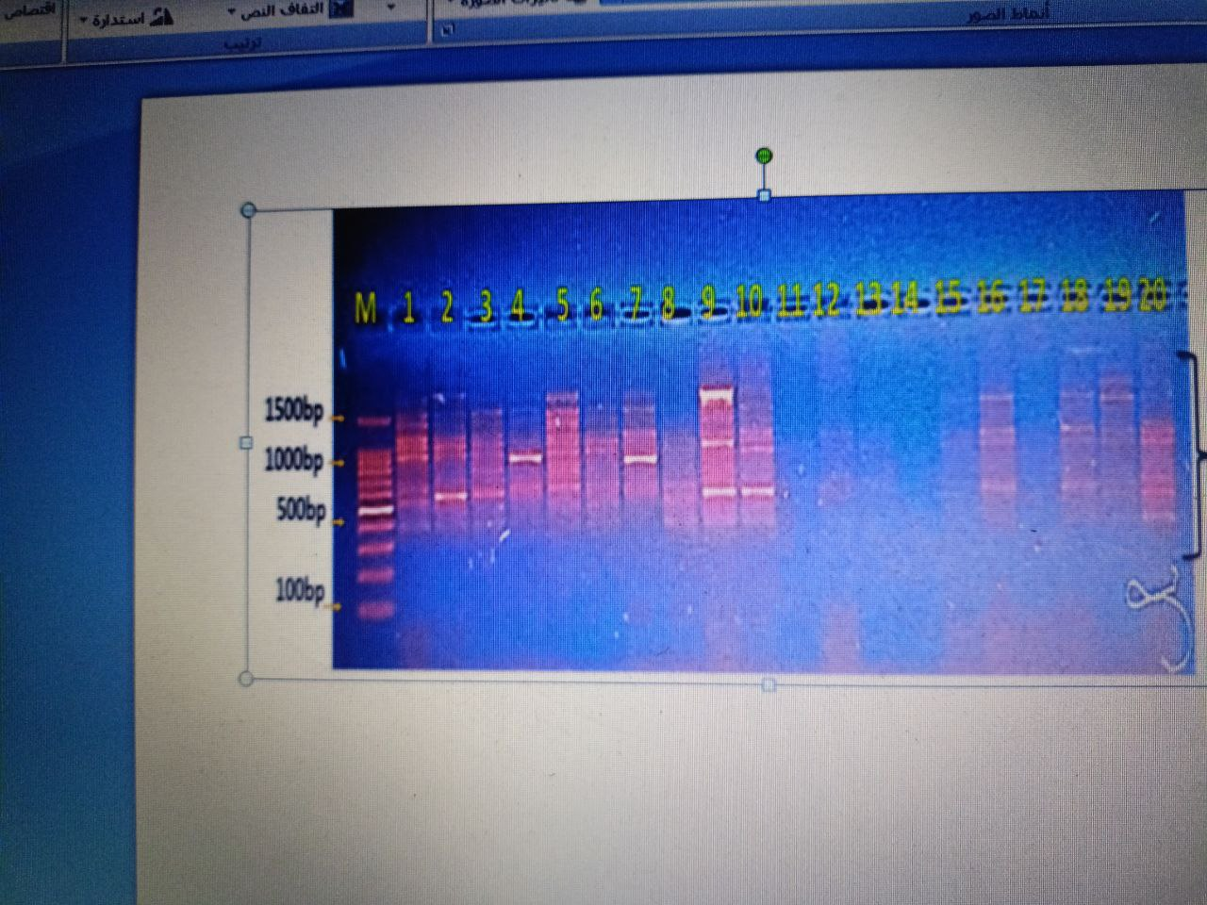

250-1000pb

**pb1000**

**500pb**

**100 pb**

**Ladder S1 S2 S3 S4 S5 S6 S7 S8 S9 S10**

Figure (2): Gel electrophoresis image showing the results of RAPD-PCR (random amplified polymorphic polymerase chain reaction) analysis for 10 samples of Salmonella bacteria**.**

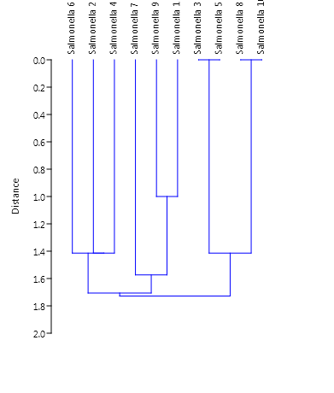

IV

I

V

Figure (3) describe RAPD-PCR dendrogram tree analysis for Eric gene in *Salmonella spp.* isolates using (Paleontological Statistics).The cluster analysis using (algorithm Ward's technique) revealed four cluster variations among 8 polymorphic variants in 20 *salmonella*  isolates.

The study underscored the importance of continuous surveillance of Salmonella outbreaks in animals and emphasized the need for more judicious use of antibiotics in veterinary medicine to control the emergence of resistant strains [15].

**4- CONCLUSION**

Domestic dogs serve as a reservoir for invasive Salmonella, which causes intestinal diarrhea in humans, necessitating strict hygiene measures to prevent transmission to humans, **Dietary** Habits: Dogs More likely to consume a varied diet, including raw meat and commercial pet food that may be contaminated. While cats typ While cats generally consume a more consistent diet, often comprising commercial cat food, which is likely to be less susceptible to contamination.

**REFERENCES**

1. Rodriguez-Rivera, L. D., Wright, E. M., Siler, J. D., Elton, M., Cummings, K. J., Warnick, L. D., & Wiedmann, M. (2014). Subtype analysis of *Salmonella* isolated from subclinically infected dairy cattle and dairy farm environments reveals the presence of both human- and bovine-associated subtypes. *Veterinary Microbiology, 170*(3–4), 307–316.
2. Herrero-Fresno, A., & Olsen, J. E. (2018). *Salmonella* Typhimurium metabolism affects virulence in the host–A mini-review. *Food Microbiology, 71*, 98–110.
3. Kozak, M., Horosova, K., Lasanda, V., Bilek, J., & Kyselova, J. (2003). Do dogs and cats present a risk of transmission of salmonellosis to humans? *Bratislavske Lekarske Listy, 104*(10), 323–328.
4. Kshirsagar, D. P., Singh, S., Brahmbhatt, M. N., & Nayak, J. B. (2014). Isolation and molecular characterization of virulence-associated genes of *Salmonella* from buffalo meat samples in western region of India. *Israel Journal of Veterinary Medicine, 69*(4), 228–233.
5. Kurowski, P. B., Traub-Dargatz, J. L., Morley, P. S., & Gentry-Weeks, C. R. (2002). Detection of *Salmonella* spp. in fecal specimens by use of real-time polymerase chain reaction assay. *American Journal of Veterinary Research, 63*(9), 1265–1268.
6. Mahon, C. R., Lehman, D. C., & Manuselis, G. (2022). *Textbook of diagnostic microbiology* (6th ed.). Elsevier Health Sciences.
7. Hashemi, A., & Baghbani‐Arani, F. (2015). The effective differentiation of *Salmonella* isolates using four PCR‐based typing methods. *Journal of Applied Microbiology, 118*(6), 1530–1540.
8. Markey, B., Leonard, F., Archambault, M., Cullinane, A., & Maguire, D. (2013). *Clinical veterinary microbiology* (2nd ed.). Elsevier Health Sciences.
9. Naravaneni, R., & Jamil, K. (2005). Rapid detection of food-borne pathogens by using molecular techniques. *Journal of Medical Microbiology, 54*(1), 51–54.
10. Oliveira, S. D., Rodenbusch, C. R., Michael, G. B., Cardoso, M. I., Canal, C. W., & Brandelli, A. (2003). Detection of virulence genes in *Salmonella Enteritidis* isolated from different sources. *Brazilian Journal of Microbiology, 34*, 123–124.
11. Parungao, S. P., Gordoncillo, M. J. N., Baldrias, L. R., & Ramirez, T. J. (2010). Isolation and molecular detection of *Salmonella* spp. from the feces of apparently healthy dogs. *Philippine Journal of Veterinary Medicine, 47*(2), 73–77.
12. Abatcha, M. G., Zunita, Z., Gurmeet, D., & Thong, K. L. (2014). Occurrence of antibiotic resistant *Salmonella* isolated from dogs in Klang Valley, Malaysia. *Malaysian Journal of Veterinary Research*, *5*(2), 17–22. *(Note: Assumed journal title and details for APA format—please confirm or provide full source.)*
13. Nde, C. W., & Logue, C. M. (2008). Characterization of antimicrobial susceptibility and virulence genes of *Salmonella* serovars collected at a commercial turkey processing plant. *Journal of Applied Microbiology, 104*(1), 215–223.
14. Salehi, T. Z., Badouei, M. A., Madadgar, O., Ghiasi, S. R., & Tamai, I. A. (2013). Shepherd dogs as a common source for *Salmonella enterica* serovar Reading in Garmsar, Iran. *Turkish Journal of Veterinary and Animal Sciences, 37*(1), 102–105.
15. Ramos, C. P., Xavier, R. G. C., Leal, C. A. G., Facury Filho, E. J., Carvalho, A. U. D., Viegas, F. M., & Silva, R. O. S. (2018). Antimicrobial susceptibility and molecular characterization of *Salmonella* serovar Ndolo isolated from outbreaks in cattle and horses. *Ciência Rural, 48*(12), e20180688.

**إنتشار بكتيريا السالمونيلا المسببة للإسهال في الكلاب والقطط المنزلية وتشخيص إختلافاتها الجينية في محافظة الديوانية في العراق**

**الـخـلاصـة**

هدفت الدراسة إلى التحقق من انتشار بكتيريا السالمونيلا في الكلاب والقطط المصابة بالإسهال للفترة (من أكتوبر 2024 إلى مارس 2025)، حيث تم جمع 40 عينة وتقسيمها إلى مجموعتين (20 عينة كلاب) و (20 عينة قطط).

تم عزل بكتيريا السالمونيلا وتشخيصها باستخدام الطرق المظهرية والكيمو حيوية والجزيئية. حيث بلغ عدد العزلات الإيجابية المؤكدة 10 عزلات، بنسبة تمثل ( 40٪)، موزعة على النحو التالي: 7 كلاب و 3 قطط. كما تم تقييم وجود جينات الضراوة invA و SiTc لجميع عزلات السالمونيلا الإيجابية الزرع . كان جين SiTc منتشرًا بنسبة 30٪ (3: 2 كلاب 1قطط)، بينما جين invA كان منتشرًا بنسبة 100٪، مما يجعله أداة تشخيصية فعالة لتفاعل البوليميراز المتسلسل (PCR) للسالمونيلا.

كما تم تحديد التنوع الجيني للبكتيريا قيد الدراسة باستخدام تقنية PCR RAPD. أظهرت نتائج تفاعل البوليميراز المتسلسل (RAPD PCR) وجود تباين جيني بين العزلات العشر المُشخَّصة، وتوزيعها على ثلاث مجموعات (I، V، IV) بإجمالي 4 تباينات. ختامًا، تجدر الإشارة إلى أن الكلاب، وخاصةً المنزلية منها، تُشكّل مستودعًا لبكتيريا السالمونيلا الغازية، لذا يحتاج المجتمع إلى إجراءات صحية صارمة لمنع انتقالها إلى البشر.