**The Role of Obesity in the Development of Type2 Diabetes**

**Zainab Samir Yahya Hammo1*, Abdulrahman Jihad Mansoor2 and Mina Dawood Mustafa1**

1Department of Physiology, College of Medicine, University of Tikrit, Iraq

2Department of Physiology, College of Nursing, University of Tikrit, Iraq

|  |  |  |
| --- | --- | --- |
| **Article Info** |  | **ABSTRACT** |
| ***Article history:***  Received April, 12, 2025  Revised May, 20, 2025  Accepted June, 25, 2025 |  | Obesity is a major cause of Type 2 Diabetes Mellitus (T2DM) and there is growing evidence that adiposity is a determinant of insulin resistance and metabolic complications. The present study was conducted to explore the effect of obesity severity on the onset of Type 2 Diabetes Mellitus (T2DM). The cross-sectional study was conducted in Tikrit, Iraq, and the data were collected from the laboratory records of Tikrit Teaching Hospital and different clinics in the city between September 2024 and January 2025. A total of 120 male patients 30–60 years of age. Lipid profiles were done using an automated analyzer and adiponectin was measured by ELISA. HbA1c and fasting blood sugar (FBS) were used to assess glycemic control; they measured in the morning, fasting at least 8 hours. Metabolic parameters were found to worsen with the severity of obesity. Lipid profile, FBS and HbA1c levels were all higher across obesity categories (p < 0.01), while HDL and adiponectin levels were lower. In obese patients, HbA1c was positively associated with TG (R = 0.640, p < 0.01) and VLDL (R = 0.525, p < 0.01) and inversely related with HDL (R = -0.519, p < 0.01) and adiponectin (R = -0.611, p < 0.01). The prevalence of hypertension, coronary heart disease, and diabetes was found to rise with the severity of obesity. The study concludes that obesity has a severe impact on metabolic dysfunction and HbA1c is a good marker of worsening lipid and glycemic status. The adverse metabolic effects of obesity may, therefore, be prevented by adiponectin. |
| ***Keywords:***  Obesity,  Diabetes Mellitus,  HbA1c,  Adiponectin,  Lipid profiles |
|  |
| ***Corresponding Author:***  * Zainab Samir Yahya Hammo Department of Physiology, College of Medicine, University of Tikrit, Iraq Email: [zainab.samir@tu.edu.iq](mailto:zainab.samir@tu.edu.iq) | | |

**1- INTRODUCTION**

The standard of living has increased tandem with the rapid advancement in modernization, urbanization and economic development, however, at the same time has led to increased stress, sedentary lifestyle and poor diet worldwide over the past two decades [1]. Obese has become a global epidemic in the past two decades that affect nearly every organ system and at present, is a major public health issue and one of the most common Non-Communicable Diseases (NCDs) [2,3]. It is important to recognize that obesity is one of the most important global challenges and affects every country without exception, and the effect is expected to become even worse in the current decade. It is a cause of more lost healthy years, higher rates of disability and more deaths before the age of retirement [4].

Obesity can be classified as a disease on its own [5]. Obesity is defined as the accumulation of excess body fat that may cause health problems and is based on a BMI of (>30) kg/m². Overweight is defined as a BMI of (25-30) kg/m², while obesity is defined as a BMI (>30) kg/m² [6]. Obesity is associated with increased risks of many chronic diseases, such as cardiovascular disease, type 2 diabetes, sleep disorders (including obstructive sleep apnea), certain cancers and osteoarthritis, which in turn lead to disability [7]. This has led to an increase in obesity in all age groups as the primary driver of the rise in the incidence of type 2 diabetes (T2DM) [8].

Diabetes is a long-term illness which is characterized by either the pancreas not producing enough insulin or the body not using the insulin produced effectively. Hyperglycemia or high blood glucose levels are a result of this [9]. In 2022, the prevalence of diabetes was 14% of the population aged 18 and above in the world, is an increase from 7% in 1990. Furthermore, half of the adults aged 30 and older with diabetes were not taking medicines for their disease. Interestingly, the lowest treatment accessibility of diabetes was observed in low-and-middle income countries. In the year 2021, diabetes was the immediate cause of about 1.6 million deaths globally. Moreover, half of the diabetes related deaths took place before the age of 70. Also, diabetes was associated with 530,000 deaths due to kidney disease and 11% of deaths due to cardiovascular disease through glucose levels [10, 11]. Mortality rates from diabetes have been rising worldwide since 2000. However, the risk of dying from one of four major non-communicable diseases between the ages of 30 and 70 has fallen by nearly 20% in the world between 2000 and 2019 [12].

A number of investigations have been conducted to determine the link between the evolution of obesity and type 2diabetes (T2DM). A significant finding is that the genetic and epigenetic overlaps with these two metabolic disorders being evident from Genome Wide Association Studies (GWAS) [13]. When environmental factors superimpose on the genetic predisposition to promote obesity and diabetes, the fat tissue grows abnormally and accumulates nutrients and metabolites, which in turn, disturb the metabolic homeostasis. This is accomplished through the pathways of insulin resistance, autophagy dysfunction and the microbiome-gut-brain axis. Systemic inflammation is known to be escalated by these disruptions and immunometabolism is, in turn, dysregulated to accelerate the deterioration of β-cell function and step by step increase in blood glucose [14, 15]. Due to the fact that they are closely interlinked in their formation, the management of obesity and type 2diabetes (T2DM) is quite similar and involves lifestyle changes, pharmacotherapy, advanced medical devices, and recently popular and sophisticated bariatric surgery [16]. The aim of the present study is to determine the relationship between the severity of obesity and the incidence of Type 2 Diabetes Mellitus (T2DM) through metabolic, clinical and biochemical analysis of participants in different obesity classes.

**2- METHOD AND STATISTICAL ANALYSIS**

**2.1 Study Design**

This case-control study was designed to evaluate the relationship between obesity and type 2 diabetes mellitus (T2DM) and to also assess the associated clinical and biochemical parameters. Patients’ records were reviewed retrospectively and patients were grouped according to obesity classification.

**2.2 Study Setting and Duration**

The study was carried out in Tikrit, Iraq, using laboratory data from Tikrit Teaching Hospital and different clinics in the city. The data was collected from the 1st of September 2024 to the 1st of January 2025.

**2.3 Study Population**

120 adult male patients, 30–60 years of age were included in this study. Participants were allocated into four groups according to Body Mass Index (BMI): Control group (C) Normal BMI (n=30), Obese Class 1 (G1) BMI 30–34.9 (n=30), Obese Class 2 (G2) BMI 35–39.9 (n=30) and Obese Class 3 (G3): BMI ≥ 40 (n=30). Patients were included if they met the following criteria: Having complete medical and laboratory records of the parameters studied.

**2.4 Data Collection and the Time Collection**

For analysis, data were collected from laboratory records and included the following parameters: age and sex, presence of hypertension, coronary heart disease (CHD), pancreatic disease, liver disease, smoking status, and frequency of fast-food consumption. Clinical Data: cholesterol, TG, HDL, LDL and VLDL were quantified biochemically from plasma using an automated analyzer. Glycemic Control Markers: HbA1c and FBS were quantified using a spectrophotometer, they were measured in the morning, fasting at least 8 hours. Adipokine: Adiponectin levels were determined by an ELISA [17].

**2.5 Statistical Analysis**

The data were analyzed using SPSS version 22. All variables were calculated for all variables including mean, standard deviation and percentages. One way ANOVA was used to compare continuous variables across the four groups, and chi square tests were done for categorical variables. Correlation coefficient was calculated for the relationship of HbA1c with other biochemical parameters across the different obesity classes. A p value of less than 0.05 was considered to be statistically significant; however, highly significant results were noted for p value less than 0.01 [18].

**2.6 Ethics approval**

The local ethical council at the University of Tikrit, College of Science, Department of Biology authorized this study. The Reference No. CSEC/0202/0107 pertains to the Iraqi health ministry as of October 29, 2022. The research was performed in accordance with the ethical guidelines established in the most recent iteration of the Declaration of Helsinki.

**3- RESULTS AND DISCUSSION**

The study in table (1) examined the association between obesity and Type 2 Diabetes Mellitus (T2DM) by comparing patient characteristics across four groups: control (C), Obese class 1 (G1), Obese class 2 (G2), and Obese class 3 (G3), with 30 patients in each group. Participants’ mean age was similar across all the groups (C: 43.76 ± 13.32 years; G1: 45.10 ± 12.06 years; G2: 44.87 ± 15.43 years; G3: 44.40 ± 14.98 years). The p-value for age differences was highly significant (<0.001), which shows that there is variability in the population we studied.

The prevalence of hypertension was increased progressively with obesity class and was 10% in the control group and 70% in G3. This association was statistically significant (p = 0.002), which supports the idea that obesity severity is a risk factor for hypertension. CHD was absent in the control group but was seen in 16.6%, 13.3%, and 33.3% of patients in G1, G2 and G3, respectively. Although the trend suggested that CHD prevalence was increasing with each obesity class, the p-value (0.052) was not quite statistically significant.

The frequency of patients with T2DM increased significantly with increasing obesity classes; 0% in the control, 12% in G1, 50% in G2, and 63.3% in G3. This association was also statistically significant (p = 0.001), which indicated a very high correlation between obesity and T2DM prevalence. Pancreatic disease was not significantly associated with obesity (p = 0.125) and the prevalence of this was 6.66%, 16.6%, and 20% in G1, G2 and G3 respectively. However, there was a statistically significant positive association of obesity with liver disease (p = 0.001) up to 46.6% in G2 and 29% in G3. Daily smoking was more prevalent among obese subjects especially in G1 (60%), G2 (73.3%) and G3 (66.6%) as compared to 20% in the control group (p = 0.003). However, the frequency of fast-food consumption increased with the groups without reaching statistical significance (p = 0.058) (Fig. 1).

**Table (1):** Comparison of patient characteristics between control (C), Obese class1 (G1), Obese class2 (G2) and Obese class3 (G3) groups, Adult Age range (30-60) years old.

|  |  |  |  |  |  |
| --- | --- | --- | --- | --- | --- |
| Variable | *No. of patients (%)* | | | | *p*‐value |
| ***C = 30*** | ***G1= 30*** | ***G2 = 30*** | ***G3 = 30*** |
| Age (years), Mean ± SD | (43.76 ± 13.32) | (45.10 ± 12.06) | (44.87 ±15.43) | (44.40± 14.98) | <0.001** |
| Hypertension | 3(10%) | 8 (26.6%) | 11 (36.6%) | 21 (70%) | 0.002** |
| Coronary Heart disease | 0 | 5(16.6%) | 4(13.3%) | 10(33.3%) | 0.052* |
| Diabetes mellitus | 0 | 12(10.6%) | 15 (50%) | 19 (63.3%) | 0.001** |
| Pancreatic disease | 0 | 2(6.66%) | 5 (16.6%) | 6(20%) | 0.125 ns |
| Liver disease | 0 | 10(33.3%) | 14(46.6%) | 27(29%) | 0.001** |
| Heavily Daily Smoker | 6(20%) | 18 (60%) | 22 (73.3%) | 20 (66.6%) | 0.003** |
| Eat fast food almost daily | 1(3.33%) | 3 (13.3%) | 7 (23.3%) | 11 (36.6%) | 0.058* |

**Note:** P: p-value; * P≤0.05; ** P≤0.01; ns: Not significant

**Figure (1):** Comparison of patient characteristics between control (C), Obese class1 (G1), Obese class2 (G2) and Obese class3 (G3) groups, Adult Age range (30-60) years old.

The analysis of biochemical and clinical parameters in the study groups Control (C), Obese Class 1 (G1), Obese Class 2 (G2), and Obese Class 3 (G3) revealed significant differences across most variables as summarized in Table (2). Total cholesterol levels rose steadily with the severity of obesity, being 178 ± 22.6 mg/dL in the control group to 241 ± 40.51 mg/dL in G3. This increase was statistically significant (p = 0.0002). Triglyceride levels also had a rising trend, starting from 132 ± 4.56 mg/dL in the control group to 199 ± 9.76 mg/dL in G3 (p = 0.0005). This finding is in concordance with the fact that obesity is linked with dyslipidemia.

HDL levels decreased steadily with obesity, 61 ± 2.99 mg/dL in the control group to 22 ± 0.60 mg/dL in G3 (p = 0.0001). This decline shows that the lipid profile deteriorates with increasing obesity severity. The levels of LDL increased steadily with the obesity class and were seen to be 90.6 ± 5.87 mg/dL in the control group and 179.2 ± 10.76 mg/dL in G3 (p = 0.0003). VLDL levels were also found to increase significantly with increasing obesity classes, the levels were 26.4 ± 2.50 mg/dL in the control group and 39.8 ± 6.60 mg/dL in G3 (p = 0.0004). HbA1c levels rose highly with obesity, starting from 4.2% in the control group to 8.3% in G3, which shows that glycemic control is poor in obese people (p = 0.0001).

Fasting blood sugar levels were again significantly higher in the obese groups than in the control group, with the control group having a mean of 81 mg/dL and G3 being 210 mg/dL (p = 0.0007). This shows a very strong relationship between obesity and glucose metabolism disturbance. Adiponectin, a hormone secreted by adipocytes that is secreted less with obesity, was reduced significantly from 7.09 ± 3.66 ng/mL in the control group to 1.05 ± 0.65 ng/mL in G3 (p = 0.0001) (Fig. 2). This rapid decrease clearly illustrates the relationship between the adiposity and the decrease in the anti-inflammatory and insulin sensitizing effects.

**Table (2):** Arithmetic average for parameters in the studied groups. Note that ages for all groups between (30-60) years old.

|  |  |  |  |  |  |
| --- | --- | --- | --- | --- | --- |
| Variable | *C = 30* | *G1= 30* | *G2 = 30* | *G3 = 30* | *p*‐value |
| Cholesterol(mg/dl) | (178 ± 22.6) | (209.70 ± 30.76) | (222 ±32.97) | (241± 40.51) | 0.0002** |
| Triglyceride (mg/ dl) | (132 ± 4.56) | (158 ± 6.87) | (177 ± 7.98) | (199 ± 9.76) | 0.0005** |
| HDL (mg/ dl) | (61± 2.99) | (34± 1.91) | (31± 1.01) | (22± 0.60) | 0.0001** |
| LDL (mg/ dl) | (90.6.6± 5.87) | (144.1± 7.09) | (155.6± 8.07) | (179.2± 10.76) | 0.0003* |
| VLDL (mg/ dl) | (26.4± 2.50) | (31.6 ± 3.87) | (35.4 ± 4.89) | (39.8 ± 6.60) | 0.0004** |
| HbA1c % | 4.2% | 5.7% | 6.8% | 8.3% | 0.0001** |
| Fasting Blood Sugar (mg\dl) | 81 | 112 | 123 | 210 | 0.0007** |
| Adiponectin (ng/ml) | (7.09±3.66) | (4.79± 2.81) | (3.99± 1.01) | (1.05± 0.65) | 0.0001** |

**Figure (2):** Arithmetic average for parameters in the studied groups. control (C), Obese class1 (G1), Obese class2 (G2) and Obese class3 (G3) groups.

A correlation analysis was conducted to determine the relationship between HbA1c and metabolic parameters in the Obese Class 1 (G1) group. The results are presented in Table (3). HbA1c had a moderate positive correlation with cholesterol (R = 0.580, p = 0.000**) (Fig. 3), which means that higher cholesterol levels are directly related to poor glycemic control. HbA1c was also found to have a moderate positive correlation with triglycerides (R = 0.572, p = 0.000**) (Fig. 4), which further supports the relationship between dyslipidemia and hyperglycemia. Moreover, TG and cholesterol were also found to be moderately correlated (R = 0.421, p = 0.048). HbA1c had a significant negative correlation with HDL (R = -0.331, p = 0.047*) (Fig. 5), which means that low levels of ‘good cholesterol’ are associated with high HbA1c levels. Other negative correlations with HDL were also observed, including with cholesterol (R = -0.580, p = 0.000**) and TG (R = -0.267, p = 0.178). HLD had a moderate negative correlation with HbA1c (R = -0.424, p = 0.032), which means that increased levels of HbA1c are associated with poor glycemic control. The LDL levels were also found to have a positive correlation with HbA1c (R = 0.424, p = 0.032), which suggests that raised LDL levels are linked with poor glycemic control. LDL also had a positive correlation with cholesterol (R = 0.455, p = 0.050*) and TG (R = 0.329, p = 0.067*).

A positive correlation of 0.587 was found between HbA1c and VLDL (P < 0.05), which is in conformity with the knowledge of altered lipid metabolism in poor glycemic control. VLDL was also found to be correlated with other lipids such as cholesterol (r = 0.540, p < 0.001) and TG (r = 0.523, p < 0.001). HbA1c was highly positively correlated with glucose levels (r = 0.599, p < 0.001), as expected from its role as a marker of glycemic control. Glucose levels were also found to be positively associated with cholesterol (r = 0.568, p < 0.001) and TG (r = 0.519, p < 0.001), while there was a negative correlation with HDL (r = −0.601, p < 0.001). A moderate negative correlation between HbA1c and adiponectin levels (r = −0.427, p = 0.057*) was observed (Fig. 6), which is consistent with the anti-inflammatory and insulin-sensitizing action of adiponectin. Adiponectin was also found to have negative correlations with LDL (r = −0.429, p = 0.053*) and TG (r = −0.356, p = 0.064*).

**Table (3):** Correlation coefficient (R) between HbA1c with other parameters in patients (G1)

|  |  |  |  |  |  |  |  |
| --- | --- | --- | --- | --- | --- | --- | --- |
| *LDL* | *HDL* | *TG* | *Cholesterol* | *HbA1c* | Statistical variables | *Parameters* | |
|  |  |  |  | 0.580 | **R** | ***Cholesterol*** | |
|  |  |  |  | 0.000** | **P** |
|  |  |  | 0.421 | 0.572 | **R** | ***TG*** | |
|  |  |  | 0.048* | 0.000** | **P** |
|  |  | -0.267 | -0.580 | -0.331 | **R** | ***HDL*** | |
|  |  | 0.178ns | 0.000** | 0.047* | **P** |
|  | -0.455 | 0.421 | 0.329 | 0.424 | **R** | ***LDL*** | |
|  | 0.050* | 0.063* | 0.067* | 0.032* | **P** |
| 0.547 | -0.536 | 0.540 | 0.523 | 0.587 | **R** | ***VLDL*** | |
| 0.000** | 0.001** | 0.001* | 0.000** | 0.000** | **P** |
| 0.389 | -0.601 | 0.568 | 0.519 | 0.599 | **R** | ***Glucose*** | |
| 0.070* | 0.000** | 0.000** | 0.001** | 0.000** | **P** |
| -0.429 | 0.277 | -0.356 | -0.365 | -0.427 | **R** | ***Adiponectin*** | |
| 0.053* | 0.111ns | 0.064* | 0.462ns | 0.057* | **P** |
| Glycated hemoglobin, or HbA1c; TG: Triglyceride; HDL: High density lipoprotein; VLDL: Very low-density lipoprotein; LDL: Low density lipoprotein R: correlation coefficient; P: p-value; ** P0.01; * P0.05; ns: Not significant. | | | | | | | |

**Figure (3):** Correlation between HbA1c with **Figure (4):** Correlation between HbA1c with TG

Cholesterol in G1 patients in G1 patients

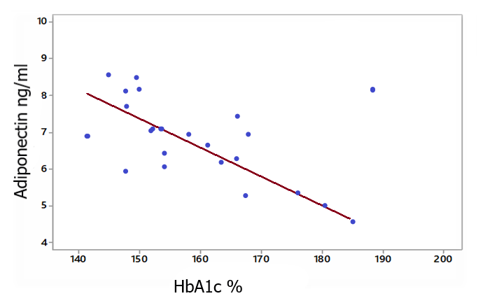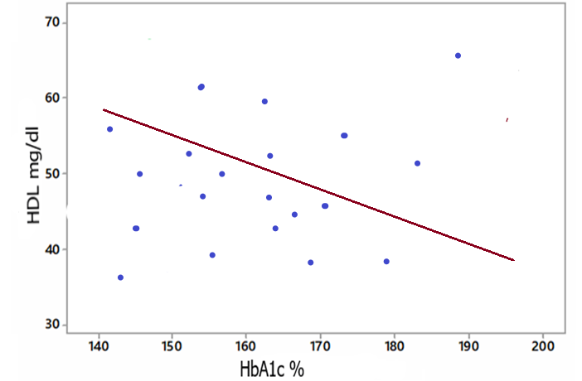

**Figure (5):** Correlation between HbA1c **Figure (6)**: Correlation between HbA1c with Adiponectin with HDL in G1 patients in G1 patients

The correlation analysis in the Obese Class 2 (G2) group was done to determine the relationships between HbA1c and other metabolic parameters. The results, presented in table (4), show that there are associations between glycemic control and lipid profile abnormalities. HbA1c had a moderate positive correlation with total cholesterol levels (R = 0.511, p = 0.000**). HbA1c also had a moderately positive correlation with triglyceride levels (R = 0.567, p = 0.000**). Moreover, TG was found to have a positive correlation with cholesterol (R = 0.461, p = 0.037*). HbA1c was negatively correlated with HDL (R = –0.623, p = 0.000**) since “good cholesterol” decreases with increasing HbA1c. Similar negative correlations were observed between HDL and TG (R = –0.424, p = 0.050*) and cholesterol (R = –0.399, p = 0.028*). No correlation was found between HbA1c and LDL levels (R = –0.211, p = 0.182, ns). However, LDL had weak positive correlations with cholesterol (R = 0.351, p = 0.046*) and TG (R = 0.342, p = 0.069**). A positive correlation was found between HbA1c and VLDL (R = 0.505, p = 0.000**) which suggests its involvement in the pathogenesis of dyslipidemia in poor glycemic control. VLDL also had positive correlations with cholesterol (R = 0.444, p = 0.029*) and TG (R = 0.444, p = 0.029*). HbA1c had a moderate positive correlation with glucose level (R = 0.524, p = 0.000*), which supports its use as a glycemic control indicator. Glucose had positive correlations with TG (R = 0.574, p = 0.000**) and cholesterol (R = 0.446, p = 0.051*) and had negative correlations with HDL (R = –0.504, p = 0.000**). There was a moderate negative correlation between HbA1c and adiponectin (R = –0.548, p = 0.000**) in Fig. 10, which shows that low adiponectin levels are associated with poor glycemic control. Adiponectin also had weak negative correlations with TG (R = –0.398, p = 0.061*) and LDL (R = –0.399, p = 0.052*).

**Table (4):** Correlation coefficient (R) between HbA1c with other parameters in patients (G2)

|  |  |  |  |  |  |  |
| --- | --- | --- | --- | --- | --- | --- |
| *LDL* | *HDL* | *TG* | *Cholesterol* | *HbA1c* | Statistical variables | Parameters |
|  |  |  |  | 0.511 | **R** | ***Cholesterol*** |
|  |  |  |  | 0.000** | **P** |
|  |  |  | 0.461 | 0.567 | **R** | ***TG*** |
|  |  |  | 0.037* | 0.000** | **P** |
|  |  | -0.399 | -0.424 | -0.623 | **R** | ***HDL*** |
|  |  | 0.028* | 0.050* | 0.000** | **P** |
|  | -0.211 | 0.297 | 0.342 | 0.351 | **R** | ***LDL*** |
|  | 0.182ns | 0.144ns | 0.069** | 0.046* | **P** |
| 0.503 | -0.387 | 0.444 | 0.258 | 0.505 | **R** | ***VLDL*** |
| 0.000** | 0.070* | 0.029* | 0.177ns | 0.000** | **P** |
| 0.540 | -0.504 | 0.574 | 0.446 | 0.524 | **R** | ***Glucose*** |
| 0.000** | 0.000** | 0.000** | 0.051* | 0.000** | **P** |
| -0.399 | 0.297 | -0.398 | -0.201 | -0.548 | **R** | ***Adiponectin*** |
| 0.052* | 0.061* | 0.061* | 0.187ns | 0.000** | **P** |

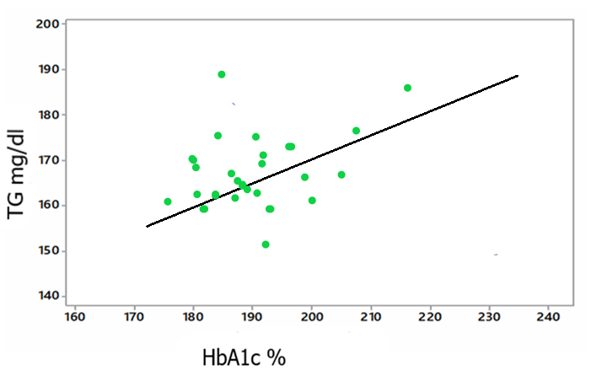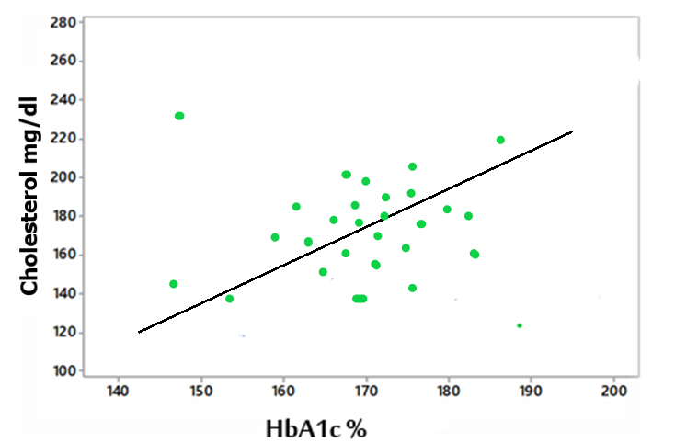

**Figure (7):** Correlation between HbA1c with **Figure (8):** Correlation between HbA1c with TG in G2 Cholesterol in G2 patients patients

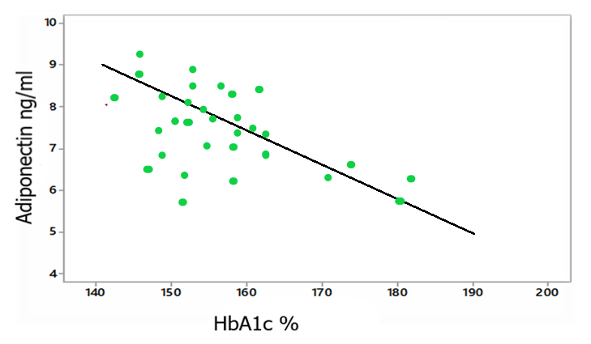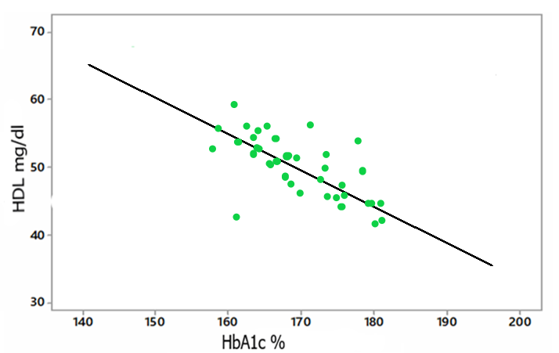

**Figure (9):** Correlation between HbA1c with **Figure (10):** Correlation between HbA1cwith Adiponectin in HDL in G2 patients G2 patients

The correlation analysis in the Obese Class 3 (G3) group was on the relationships between HbA1c and metabolic parameters. The results, shown in Table (5), reveal distinctive patterns of dysregulation in the glycemic and lipid profiles. HbA1c was found to have a positive correlation with cholesterol levels (R = 0.509, p = 0.000**) (Fig. 11), which means that high cholesterol is closely linked with poor glycemic control in obese people.

A very high value of R was found between HbA1c and TG levels (R=0.640, P=0.000**) (Fig. 12). Also, TG had positive correlations with cholesterol (R=0.431, P=0.030*). HbA1c had a negative correlation with HDL (R= -0.519, P=0.000**) (Fig. 13), which shows that glycemic control gets worse with lower levels of “good cholesterol.” Other negative correlations of HDL with TG (R= -0.509, P=0.000**) and cholesterol (R= -0.241, P=0.120 ns) were also observed. LDL had a moderate positive correlation with HbA1c (R= 0.421, P= 0.037 *), which means that raised LDL is associated with poor glycemic control. The levels of LDL also correlated with cholesterol (R= 0.396, P= 0.044*) and TG (R= 0.412, P= 0.029*). HbA1c was found to be highly positively correlated with VLDL (R= 0.525, P= 0.000**), which indicates that it is associated with dyslipidemia in severe obesity. The VLDL levels were also found to be positively correlated with cholesterol (R= 0.431, P= 0.028*) and TG (R= 0.512, P= 0.000**). A very high positive correlation was observed between HbA1c and glucose (R= 0.721, P= 0.000**) which justify the use of HbA1c as a marker of glycemic control. Glucose also had positive correlations with TG (R= 0.610, P= 0.000**) and cholesterol (R= 0.521, P= 0.000**) and a negative correlation with HDL (R= -0.587, P= 0.000**). A very high negative correlation was observed between HbA1c and adiponectin (R= -0.611, P= 0.000**) (Fig. 14), which is in accordance with the reverse trend seen between this insulin sensitizing hormone and glycemic control. Adiponectin also had negative correlations with cholesterol (R= -0.562, P= 0.000**) and TG (R= -0.398, P= 0.029*).

**Table (5):** Correlation coefficient (R) between HbA1c with other parameters in patients (G3)

|  |  |  |  |  |  |  |  |  |  |
| --- | --- | --- | --- | --- | --- | --- | --- | --- | --- |
| *LDL* | *HDL* | *TG* | *Cholesterol* | *HbA1c* | Statistical variables | | parameters | | |
|  |  |  |  | 0.509 | **R** | | ***Cholesterol*** | | |
|  |  |  |  | 0.000** | **P** | |
|  |  |  | 0.431 | 0.640 | **R** | | ***TG*** | | |
|  |  |  | 0.030* | 0.000** | **P** | |
|  |  | -0.241 | -0.509 | -0.519 | **R** | | ***HDL*** | | |
|  |  | 0.120ns | 0.000** | 0.000** | **P** | |
|  | -0.351 | 0.396 | 0.412 | 0.421 | **R** | | ***LDL*** | | |
|  | 0.062* | 0.044* | 0.029* | 0.037* | **P** | |
| 0.512 | -0.459 | 0.431 | 0.358 | 0.525 | **R** | | ***VLDL*** | | |
| 0.000** | 0.021** | 0.028* | 0.068* | 0.000** | **P** | |
| 0.606 | -0.587 | 0.610 | 0.521 | 0.721 | **R** | | ***Glucose*** | | |
| 0.000** | 0.000** | 0.000** | 0.000** | 0.000** | **P** | |
| -0.474 | 0.389 | -0.398 | | -0.562 | | -0.611 | | **R** | ***Adiponectin*** |
| 0.050* | 0.060* | 0.029* | | 0.000** | | 0.000** | | **P** |

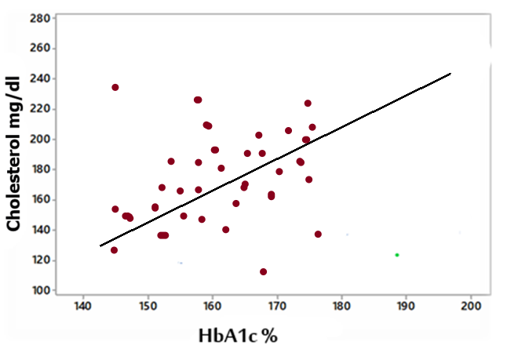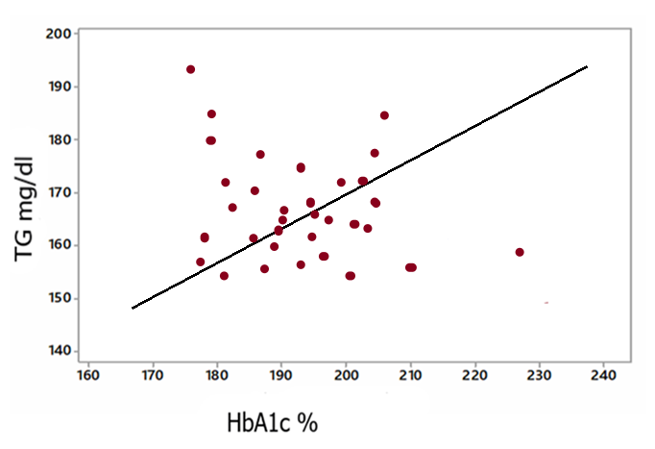

**Figure (11):** Correlation between HbA1c with **Figure (12):** Correlation between HbA1c with TG in G3 Cholesterol in G3 patients patients

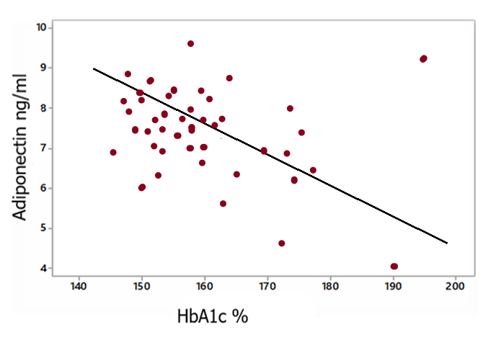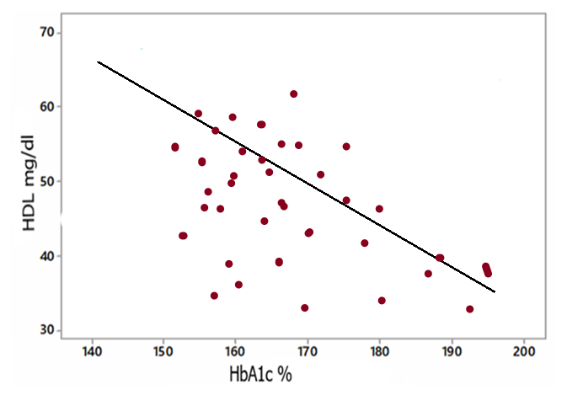

**Figure (13):** Correlation between HbA1c **Figure (14):** Correlation between HbA1c with

Adiponectin in G3 with HDL in G3 patients G3 patients

In the current study, Hypertension rates increased with each level of obesity and were found to be 10% among the non-obese, 40% among the obese, 60% among the more obese and 70% among the severely obese patients. This is in concurrence with other studies that have established obesity as a major contributor to high blood pressure [19].

The mechanisms through which obesity impacts blood pressure include: Overactivation of the sympathetic nervous system; Alterations to kidney function resulting in sodium retention and increased blood volume; Shift in hormone levels that can include renin, angiotensinogen, and aldosterone, all of which can raise blood pressure; Insulin resistance and associated inflammation that can adversely affect vascular function; and, finally, leptin and other neuropeptides may also participate in the process [20].

In the current study, the rates of patients with T2DM increased with increasing obesity levels; none in the control group, 12% in G1, 50% in G2, and 63.3% in G3. Obesity is a leading cause of type 2 diabetes (T2DM) (36). Obesity is now recognized as a leading cause of type 2 diabetes in children and young adults, especially those who are severely obese. It is speculated that obesity results in type 2 diabetes of children and young adults because insulin resistance of muscles is known to develop before individuals become obese. In other words, obesity may be a manifestation or outcome of underlying insulin resistance and not necessarily the cause of T2DM [21].

In the current study it was established that liver disease severity increased with obesity (p = 0.001), ranging from 29% in G3 to 46.6% in G2. Non-alcoholic fatty liver disease (NAFLD) is currently the leading cause of liver disease globally, ranging from simple steatosis to non-alcoholic steatohepatitis (NASH). It is associated with metabolic syndrome, most especially obesity and insulin resistance. About 80% of NAFLD patients are obese and visceral adipose tissue is a main driver of insulin resistance [22]. Free fatty acids from the visceral fat, diet and production by the liver cause liver injury and inflammation. Adipokines and lipid accumulation in the liver worsen inflammation and insulin resistance through certain signaling pathways [23]. In NASH patients, the severity of liver steatosis increases with BMI, waist circumference, blood sugar and lipid profiles abnormalities. It is a clinical problem to determine obese subjects who are likely to have simple fatty liver to NASH and may go to fibrosis or cirrhosis [24]. Daily smoking was more frequent in obese groups and was especially high in G1 (60%), G2 (73.3%) and G3 (66.6%) compared to 20% in the control group (p = 0.003). However, this is inconsistent with the results of other studies which posited that smoking was associated with lower BMI and obesity rates [25].

Cholesterol levels also increased with rising obesity; the levels were 178 ± 22.6 mg/dL in the control group and 241 ± 40.51 mg/dL in G3. This increase was statistically significant (p = 0.0002). A study was conducted to investigate the prevalence of high cholesterol levels and their relationship with abdominal obesity among adults (25-65 years old) in northern Iran. The results revealed that about half of the participants had high cholesterol levels, and women were more likely to be affected than men. High cholesterol levels were found to be closely associated with abdominal obesity, especially among the younger participants [26]. Triglyceride levels also increased with obesity; they rose from 132 ± 4.56 mg/dL in the control group to 199 ± 9.76 mg/dL in G3 (p = 0.0005). This finding is significant as it highlights the link between obesity and dyslipidemia. Since adipose tissue also accumulates significant levels of free cholesterol and triglycerides [27].

HDL levels were significantly decreased with obesity; the levels were 61 ± 2.99 mg/dL in the control group and 22 ± 0.60 mg/dL in G3 (p = 0.0001). This decrease denotes a worsening of the lipid profile with the increasing severity of obesity. Intra-abdominal visceral fat deposition is a key factor in the reduction of HDL-cholesterol and the mechanisms of low HDL in obesity have been suggested to involve enhanced uptake by adipocytes, increased catabolism of apolipoprotein A-I, and decreased conversion of the pre-β1 subfraction [28]. The levels of LDL increased with the severity of obesity, and the levels were 90.6 ± 5.87 mg/dL in the control group and 179.2 ± 10.76 mg/dL in G3 (p = 0.0003). It has been established that excess adiposity is a marker of a specific dyslipidemia consisting of increased triglycerides, low HDL-C, high non-HDL-C, and high LDL particle number [29].

From 26.4 ± 2.50 mg/dL in the control group to 39.8 ± 6.60 mg/dL in G3 (p = 0.0004), very-low-density lipoprotein (VLDL) levels likewise displayed a notable rise across groups. This is consistent with research showing that VLDL cholesterol levels in obese individuals were much greater than those of persons with normal weight [30]. From 4.2% in the control group to 8.3% in G3, glycated hemoglobin (HbA1c) levels rose significantly with obesity, signifying poor glycemic management in more obese persons (p = 0.0001). Physical inactivity during leisure time was found to be significantly correlated with variations in glucose homeostasis in research comprising approximately 1,600 Brazilian individuals. Those who were physically inactive were more than twice as likely to have glycemic changes—that is, high blood sugar levels—according to the study. Over an 8-year period, Japanese people were tracked for long time with regard to weight and blood sugar levels. With half of them showing this development during the 8-year period, the findings revealed that obese people with normal blood sugar levels were more likely to acquire prediabetes or diabetes [30].

Obese groups had notably higher fasting blood sugar levels; the mean of the control group in G3 is 81 mg/dL while 210 mg/dL in obese groups (p = 0.0007). This emphasizes the great correlation between obesity and poor glucose metabolism. This is consistent with the results of a study showing that, in both male (4.07 mmol/l) and female (5.58 mmol/l) obese people, fasting blood glucose levels were considerably higher than in their non-obese counterparts [31]. Reduced considerably from 7.09 ± 3.66 ng/mL in the control group to 1.05 ± 0.65 ng/mL in G3 (p = 0.0001), adiponectin is an adipocyte-secreted hormone inversely connected to obesity. This dramatic drop emphasizes how closely diminished anti-inflammatory, insulin-sensitizing actions are linked to obesity. Low levels of adiponectin have been linked to insulin resistance, diabetes, heart disease, thyroid illness, and thyroid cancer [32, 33].

**4- CONCLUSION**

The present investigation shows, together with several clinical and biochemical criteria, a strong and substantial correlation between obesity degree and the development of Type 2 Diabetes Mellitus (T2DM). The statistics show that the frequency of chronic diseases including hypertension, coronary heart disease (CHD), liver disease, and T2DM grows significantly as obesity gets more severe. Furthermore, exposed by the study are notable metabolic anomalies in glycemic control, adiponectin levels, and lipid profiles across the several obesity stages.

Particularly with higher total cholesterol, triglycerides, LDL, and VLDL levels, the study underlines even more the intimate association between poor glycemic management and dyslipidemia, as demonstrated by raised HbA1c levels, and lowered HDL levels. Especially, the correlation study shows that poorer lipid profiles are closely linked with higher HbA1c levels, thereby verifying the metabolic dysfunctions linked with obesity. Moreover, inversely connected to obesity degree, lower adiponectin levels highlight the function of adiponectin as a preventive agent against insulin resistance and inflammation. Furthermore, underlined by the results is the need of addressing obesity as a main determinant of T2DM and associated comorbidities. The rising frequency of smoking and fast-food consumption among obese people emphasizes the need of focused public health campaigns addressing lifestyle elements causing obesity and its consequences.

**REFERENCES**

1. Blüher, M. (2019). Obesity: Global epidemiology and pathogenesis. *Nature Reviews Endocrinology, 15*(5), 288–298. <https://doi.org/10.1038/s41574-019-0176-8>
2. Kumanyika, S., & Dietz, W. H. (2020). Solving population-wide obesity—Progress and future prospects. *The New England Journal of Medicine, 383*(23), 2197–2200. <https://doi.org/10.1056/NEJMp2020472>
3. Tsai, A. G., & Bessesen, D. H. (2019). Obesity. *Annals of Internal Medicine, 170*(5), ITC33–ITC48. <https://doi.org/10.7326/AITC201903050>
4. Ruze, R., Liu, T., Zou, X., Song, J., Chen, Y., Xu, R., et al. (2023). Obesity and type 2 diabetes mellitus: Connections in epidemiology, pathogenesis, and treatments. *Frontiers in Endocrinology, 14*, 1161521. <https://doi.org/10.3389/fendo.2023.1161521>
5. Powell-Wiley, T. M., Poirier, P., Burke, L. E., Després, J. P., Gordon-Larsen, P., Lavie, C. J., et al. (2021). Obesity and cardiovascular disease: A scientific statement from the American Heart Association. *Circulation, 143*(21), e984–e1010. <https://doi.org/10.1161/CIR.0000000000000951>
6. World Health Organization. (n.d.). *Obesity and overweight*. Retrieved from <https://www.who.int/news-room/fact-sheets/detail/obesity-and-overweight>
7. Chiolero, A. (2018). Why causality, and not prediction, should guide obesity prevention policy. *The Lancet Public Health, 3*(10), e461–e462. <https://doi.org/10.1016/S2468-2667(18)30201-6>
8. World Health Organization. (n.d.). *Noncommunicable diseases risk factors and conditions*. Retrieved from <https://www.who.int/data/gho/data/themes/topics/noncommunicable-diseases-risk-factors>
9. Institute for Health Metrics and Evaluation. (n.d.). *Global Burden of Disease (GBD)*. Retrieved from <https://www.healthdata.org/research-analysis/gbd>
10. Ingelsson, E., & McCarthy, M. I. (2018). Human genetics of obesity and type 2 diabetes mellitus: Past, present, and future. *Circulation: Genomic and Precision Medicine, 11*(6), e002090. <https://doi.org/10.1161/CIRCGEN.118.002090>
11. Rohm, T. V., Meier, D. T., Olefsky, J. M., & Donath, M. Y. (2022). Inflammation in obesity, diabetes, and related disorders. *Immunity, 55*(1), 31–55. <https://doi.org/10.1016/j.immuni.2021.11.004>
12. Lingvay, I., Sumithran, P., Cohen, R. V., & le Roux, C. W. (2022). Obesity management as a primary treatment goal for type 2 diabetes: Time to reframe the conversation. *The Lancet, 399*(10322), 394–405. <https://doi.org/10.1016/S0140-6736(21)02199-5>
13. Nuttall, F. Q. (2015). Body mass index: Obesity, BMI, and health: A critical review. *Nutrition Today, 50*(3), 117–128. <https://doi.org/10.1097/NT.0000000000000082>
14. Zierle-Ghosh, A., & Jan, A. (2024). Physiology, body mass index. In *StatPearls*. StatPearls Publishing. Retrieved from <https://www.ncbi.nlm.nih.gov/books/NBK535456/>
15. World Health Organization. (n.d.). *Obesity*. Retrieved from <https://www.who.int/health-topics/obesity>
16. Milić, S., Lulić, D., & Štimac, D. (2014). Non-alcoholic fatty liver disease and obesity: Biochemical, metabolic and clinical presentations. *World Journal of Gastroenterology, 20*(28), 9330–9337.
17. Gümüş, A., Kayhan, S., Cinarka, H., Baydur, S., Gıakoup, D., & Şahin, Ü. (2014). The relationship between cigarette smoking and obesity. *Journal of Experimental and Clinical Medicine, 30*(4), 311–315.
18. Mishra, P., Singh, U., Pandey, C. M., Mishra, P., & Pandey, G. (2019). Application of student's t-test, analysis of variance, and covariance. *Annals of Cardiac Anaesthesia, 22*(4), 407–411. <https://doi.org/10.4103/aca.ACA_94_19>
19. Veghari, G., Sedaghat, M., Maghsodlo, S., Banihashem, S., Moharloei, P., Angizeh, A., et al. (2015). The association between abdominal obesity and serum cholesterol level. *International Journal of Applied and Basic Medical Research, 5*(2), 83.
20. Bays, H. E., Kirkpatrick, C., Maki, K. C., Toth, P. P., Morgan, R. T., Tondt, J., et al. (2024). Obesity, dyslipidemia, and cardiovascular disease: A joint expert review from the Obesity Medicine Association and the National Lipid Association. *Obesity Pillars, 10*, 100108.
21. Johansen, M. Ø., Nielsen, S. F., Afzal, S., Vedel-Krogh, S., Davey Smith, G., & Nordestgaard, B. G. (2021). Very low-density lipoprotein cholesterol may mediate a substantial component of the effect of obesity on myocardial infarction risk: The Copenhagen General Population Study. *Clinical Chemistry, 67*(1), 276–287.
22. de Moura, S. S., de Menezes-Júnior, L. A. A., Rocha, A. M. S., Batista, A. P., de Menezes, M. C., Carraro, J. C. C., et al. (2023). High levels of glycated hemoglobin (HbA1c) are associated with physical inactivity, and part of this association is mediated by being overweight. *Nutrients, 15*(5), 1191.
23. Nakajima, K., & Suwa, K. (2015). Excess body weight affects HbA1c progression irrespective of baseline HbA1c levels in Japanese individuals: A longitudinal retrospective study. *Endocrine Research, 40*(2), 63–69.
24. Hammo, Z. S. Y., Almahdawi, Z. M. M., Alsammeraie, A. Y. J., & Nasif, A. S. (2019). The role of adipokines: Leptin, resistin, and CRP in thyroid dysfunction. *Biochemical and Cellular Archives, 19*(2), 3653. <https://doi.org/10.35124/bca.2019.19.2.3653>
25. Akter, R., Nessa, A., Husain, M. F., Wahed, F., Khatun, N., Yesmin, M., et al. (2017). Effect of obesity on fasting blood sugar. *Mymensingh Medical Journal, 26*(1), 7–11.
26. Kawano, J., & Arora, R. (2009). The role of adiponectin in obesity, diabetes, and cardiovascular disease. *Journal of CardioMetabolic Syndrome, 4*(1), 44–49.
27. Unger, R. H., & Orci, L. (2010). Paracrinology of islets and the paracrinopathy of diabetes. *Proceedings of the National Academy of Sciences of the United States of America, 107*(37), 16009–16012.
28. Ojo, O. A., Ibrahim, H. S., Rotimi, D. E., Ogunlakin, A. D., & Ojo, A. B. (2023). Diabetes mellitus: From molecular mechanism to pathophysiology and pharmacology. *Medical Novelty Technology Devices, 19*, 100247.
29. Tuppad, S., Medala, K., Umesh, M., Gaur, A., Ganji, V., Sakthivadivel, V., & Kumar, P. (2022). Serum adiponectin and nitric oxide levels in type II diabetes and its correlation with lipid profile. *Cureus, 14*(4), e24613. <https://doi.org/10.7759/cureus.24613>
30. Malone, J. I., & Hansen, B. C. (2019). Does obesity cause type 2 diabetes mellitus (T2DM)? Or is it the opposite? *Pediatric Diabetes, 20*(1), 5–9.
31. de Moura, S. S., de Menezes-Júnior, L. A. A., Rocha, A. M. S., Batista, A. P., de Menezes, M. C., Carraro, J. C. C., et al. (2023). High levels of glycated hemoglobin (HbA1c) are associated with physical inactivity, and part of this association is mediated by being overweight. *Nutrients, 15*(5), 1191.
32. Bays, H. E., Kirkpatrick, C., Maki, K. C., Toth, P. P., Morgan, R. T., Tondt, J., et al. (2024). Obesity, dyslipidemia, and cardiovascular disease: A joint expert review from the Obesity Medicine Association and the National Lipid Association. *Obesity Pillars, 10*, 100108.
33. Johansen, M. Ø., Nielsen, S. F., Afzal, S., Vedel-Krogh, S., Davey Smith, G., & Nordestgaard, B. G. (2021). Very low-density lipoprotein cholesterol may mediate a substantial component of the effect of obesity on myocardial infarction risk: The Copenhagen General Population Study. *Clinical Chemistry, 67*(1), 276–287.

**دور السمنة في تطور النوع الثاني لداء السكري**

**الـخـلاصـة**

تُعَدُّ السمنة من الأسباب الرئيسية لداء السكري من النوع الثاني (T2DM)، وهناك أدلة متزايدة تشير إلى أن تراكم الدهون في الجسم يُعدّ عاملاً محددًا لمقاومة الإنسولين والمضاعفات الأيضية.

أُجريَت هذه الدراسة بهدف استكشاف تأثير شدة السمنة على ظهور داء السكري من النوع الثاني (T2DM).. أُجريت دراسة مقطعية في مدينة تكريت، العراق، وجُمعت البيانات من سجلات مختبر مستشفى تكريت التعليمي وعدة عيادات في المدينة خلال الفترة من سبتمبر 2024 إلى يناير 2025. شملت الدراسة 120 مريضًا من الذكور تتراوح أعمارهم بين 30 و60 عامًا. تم تقسيم المشاركين إلى أربع مجموعات وفقًا لمؤشر كتلة الجسم:(BMI)

المجموعة الضابطة (C): **مؤشر كتلة الجسم الطبيعي (عدد = 30)،**

السمنة من الدرجة الأولى (G1): **BMI بين 30 و34,9 (عدد = 30)،**

السمنة من الدرجة الثانية (G2): **BMI بين 35 و39,9 (عدد = 30)،**

السمنة من الدرجة الثالثة (G3): **BMI ≥ 40 (عدد = 30).**

تم إجراء تحاليل الدهون باستخدام جهاز تحليل آلي، وتم قياس مستوى الأديبونكتين باستخدام اختبار ELISA. كما تم استخدام تحليل HbA1c وسكر الدم الصيامي لتقييم التحكم في مستوى السكر، حيث أُخذت العينات صباحًا بعد صيام لا يقل عن 8 ساعات.

أظهرت الدراسة أن المؤشرات الأيضية تسوء مع ازدياد شدة السمنة. فقد كانت مستويات الكوليسترول، الدهون الثلاثية (TG)، LDL، VLDL، سكر الدم الصيامي (FBS) وHbA1c أعلى بشكل ملحوظ عبر درجات السمنة (جميعها كان p < 0.01)، بينما كانت مستويات HDL والأديبونكتين أقل. في المرضى المصابين بالسمنة، وُجد أن HbA1c يرتبط إيجابيًا بمستوى الدهون الثلاثية R = 0.640،p < 0.01) وVLDL (R = 0.525، p < 0.01)، ويرتبط عكسيًا مع HDL (R = -0.519،p < 0.01) والأديبونكتين (R = -0.611،p < 0.01) ) كما لوحظ ارتفاع في معدلات الإصابة بارتفاع ضغط الدم وأمراض القلب التاجية والسكري مع زيادة شدة السمنة.

نستنتج من هذه الدراسة أن السمنة تؤثر بشدة على الوظائف الأيضية، ويُعد HbA1c مؤشرًا جيدًا على تدهور حالة الدهون ومستويات السكر. وقد يكون من الممكن الوقاية من التأثيرات الأيضية السلبية للسمنة من خلال الأديبونكتين.