**Evaluation of Immunoglobulin Levels (IgE, IgM, and IgG) and Nasal Symptoms among Wheat Flour Mill Workers in Najaf City**

**Zaid M. Mohammed Al-Hakkak\***

Department of Ecology, Faculty of Science, University of Kufa, Najaf, Iraq

|  |  |  |
| --- | --- | --- |
| **Article Info** |  | **ABSTRACT** |
| ***Article history:***  Received May, 06, 2025  Revised June, 20, 2025  Accepted July, 28, 2025 |  | The inhalation of particles from wheat flour in the workplace has been linked to an inflammatory reaction. This study examined the frequency of nasal symptoms among wheat flour mill employees in Najaf city. The study evaluated immunological parameters, including IgE, IgG, IgM, anti-gliadin IgA and IgG antibodies, and nasal smear eosinophil count, in 48 not smokers male flour mill employees (mean age: 35.83±8.3 years, mean duration of employment: 9.22±3.16 years) and 37 unexposed non-smokers (mean age: 35.78±8.66 years).  In addition, Using a standardized questionnaire, 80 non-smoker male flour mill employees and 70 unexposed non-smokers were assessed for nasal symptoms. The study group was separated into three job-type subgroups: cleaning employees (high exposure), packing employees (intermediate), and milling employees (low exposure). The results indicated a significant rise (P≥0.05) in total IgE and IgM serum levels among packing and milling employees compared to the control group.  The results demonstrated a significantly elevated (p≥0.05) percentage of positive anti-gliadin IgG and nasal eosinophil counts in cleaning employees compared to the control group and milling employees. The study noted an elevated prevalence (p≥0.05) of nose symptoms, such as sneezing, nasal irritation, rhinitis, and nose catarrh, among all three occupational categories. The findings indicated a significant correlation (P<0.05) between average serum concentrations of IgE, IgG, and IgM and the period of employment of wheat flour mill employees. |
| ***Keywords:***  Wheat Flour Dust,  Immunological Parameters,  Nasal Symptoms,  Flour Mill Employees,  Nasal Symptoms |
|  |
| ***\*Corresponding Author:***  * Zaid M. Mohammed Al-Hakkak Department of Ecology, Faculty Of Science, University of Kufa, Najaf, Iraq.  Email: [zaid.alhakkak@uokufa.edu.iq](mailto:zaid.alhakkak@uokufa.edu.iq) | | |

**1- INTRODUCTION**

Wheat is among the most widely consumed grains worldwide. The wheat (Triticum) seed comprises three components: the endosperm (85%), the germ (2%), and the husk (13%). Wheat includes 70% carbohydrates (61.2% starch and 8.8% cellulose), 12.2% protein, 1.8% minerals, 2.0% fat, & 14% water by weight [1]. Wheat flour dust denotes particles generated from the grinding or milling of wheat. The proteins present in flour particles may induce allergic reactions [2].

Numerous scientists have determined that wheat dust can cause hypersensitivity reactions, compromising the immune response [3,4,5]. [6] evaluated wheat-specific IgE concentrations using ELISA in 80 wheat mill employees in Basrah Governorate and contrasted the findings with those of 80 normal individuals. The findings indicated that 70% of those exhibiting work-related allergic symptoms possessed a wheat-specific sensitivity. On the other hand, the control group showed no allergies, with the difference being statistically significant (P<0.01). The results revealed that the highest allergic response, specifically to wheat, was observed in 78.7% of those working in high-exposure conditions.

Furthermore, another study demonstrated that inhaling high levels of wheat flour and dust in working settings may induce an allergic reaction (type I hypersensitivity response) and immunological asthma in employees [7]. [8] direct contact with wheat flour dust triggers or worsens allergic conditions, such as dermatitis, allergenic rhinitis, and other allergic-related disorders. Nasal specimens and smear preparations facilitate the identification of cells associated with inflammation in the nasal discharge or mucosa, thus validating a diagnosis of rhinitis caused by allergies [9]. This study aimed to evaluate immunological changes and their correlations with employment length, nasal smear eosinophil levels, and frequency of nasal symptoms in wheat flour mill staff in Najaf City, Iraq.

**2- MATERIAL AND METHOD**

**2.1. Study population:**

The search was conducted between January and June 2024 at three large wheat milling plants in Najaf City, Iraq. It is related to workers at flour mills being exposed to wheat flour dust during their shifts. The workers at the wheat flour mill do at least eight to ten hours of work every day, six days a week. Immunological parameters, which include total serum IgE, IgG, IgM, as well as anti-gliadin IgA & IgG antibodies, in addition to nasal smear eosinophil count, were evaluated in 48 not smokers men flour mill staff with an age mean of 35.83±8.3 years and an average work duration of 9.22±3.16 years, compared to 37 non-smoking male control subjects. The control group has a mean age of 35.78 ± 8.66 years.

**2.2. Surveys using questionnaires:**

The prevalence of nasal symptoms was evaluated using a standardized survey administered to 80 non-smoking male employees of a flour mill, with a mean age of 34.01±8.17 years and a mean employment of 8.7±4.23 years. The control group comprised 70 unexposed non-smokers with an average age of 34.8±8.13 years. Data was gathered by interviews conducted in work environments using structured questionnaires within the three principal flour milling sectors. It included elements about personal and familial allergy history, nasal symptoms, and length of work. The study population was categorized into three subgroups based on occupational classifications: cleaning employees (high exposure group), packing employees (intermediate exposure group), and milling employees (low exposure group).

**2.3. Blood sample and immunological parameter, nasal smear eosinophil count assessments:**

Individuals who participated were given venipuncture to get blood samples, which were placed in a plastic tube that didn't have any anticoagulants. It was left to clot at room temperature within three hours of being collected and centrifuged. The serum for immunological analysis was then kept immediately in the hospital's refrigerator at -30C˚ to be used for enzyme immunoassays for inflammatory markers studies. An ELISA kit (US Biological USA) followed the maker's directions to measure the total serum of IgE, IgG, IgM, and anti-gliadin IgA and IgG antibodies. Al-Najaf Hospital examined all the blood samples.

In addition, the number of eosinophils was determined by staining nasal smear slides with Wright-Giemsa and then examining them using a light microscope. We observed eosinophils with a high magnification lens (oil immersion, × 1000). The eosinophilia in the nasal smear was graded as follows: (1) Normal, with less than 10 cells, or eosinophilia less than 5%; (2) Mild, with 10 to 30 cells, or eosinophilia more significant than 5%. According to Rakesh et al. (2002) and Abhey (2005), there are four levels of eosinophilia: moderate (many cells) at around 50%, marked (numerous cells) at >50%, and severe ( >50%).

**Statistical analysis:**

The study was done with SPSS 14 from SPSS Inc. in Chicago, USA. Because of this, the t-test for independent samples was used to compare both data sets. A one-way analysis of variance, also known as ANOVA, was used to compare numerical data within or between more than two groups, that statistical importance was set at P ≥ 0.05 [10].

**3- RESULTS**

The study found a significant increase (p≥0.05) in IgE and IgM levels between packing and milling employees compared to a control (Table 1). The research found significant (p≥0.05) increases in serum IgG levels among cleaning, Packing, and milling staff compared to the control (table 1).

**Table 1. Average IgE, IgM, and IgG serum immunoglobulin concentrations in flour mill workers by job category and control.**

|  |  |  |  |  |
| --- | --- | --- | --- | --- |
| Parameters | Control subjects  (n=37) | Wheat flour-exposed employees (n= 48) | | |
| **Cleaning**  **Employees**  **(n=16)** | **Packing**  **Employees**  **(n=16)** | Milling  Employees  (n=16) |
| **Mean±SD** | **Mean±SD** | **Mean±SD** | Mean±SD |
| Age (years) | 35.78±8.66 | 36.12±6.13 | 35.87±9.27 | 35.5±9.59 |
| Total IgE (IU/ml) | 118.36±6.6 | 177.11±46.9 | 260.6±36.2 a | 238.3±36.1 a |
| Total IgM (mg/ml) | 0.017±0.002 | 0.018±0.0008 | 0.04±0.0037 ab | 0.049±0.007 ab |
| Total IgG  ( mg/ml) | 0.2758±0.01 | 0.66±0.028 a | 0.639±0.01 a | 0.64±0.031 a |

Notes: (a) shows a statistically significant difference for the control at (P≥ 0.05). (b) = shows a statistically significant difference for cleaning workers at (P ≥ 0.05). (c) = shows a statistically significant variance compared to packing workers at (P≥ 0.05).

The statistical analysis indicated a significantly (p≥0.05) higher percentage of positive anti-gliadin IgG in cleaning employees compared to the control and milling staff (p≥0.05) (Table 2). The results revealed no significant differences in anti-gliadin IgA levels among cleaning, Packing, and milling employees compared to the control (Table 2).

**Table 2. Job roles and a control group categorized prevalence levels of anti-gliadin IgA and IgG among flour mill employees.**

|  |  |  |  |  |  |
| --- | --- | --- | --- | --- | --- |
| Parameters | | Control subjects  (n=37) | Wheat flour-exposed employees  (n= 48) | | |
| **Cleaning employees**  **(n=16)** | **Packing**  **Employees**  **(n=16)** | **Milling**  **Employees**  **(n=16)** |
| No. (%) | No. (%) | No. (%) | No. (%) |
| Serum gliadin IgG | positive | 9(24.3%) | 10(62.5%)a | 8(50%) | 4(25%)b |
| Negative | 28(75.7%) | 6(32.5%) | 8(50%) | 12(75%) |
| Serum gliadin IgA | positive | 17(45.9%) | 12(75%) | 10(62.5%) | 7(43.7%) |
| Negative | 20(54.1%) | 4(25%) | 6(32.5%) | 9(56.3%) |

Notes: (a) shows a statistically significant difference for the control at (P≥ 0.05). (b) = shows a statistically significant difference for cleaning workers at (P ≥ 0.05). (c) = shows a statistically significant variance compared to packing workers at (P≥ 0.05).

The study demonstrated a statistically significant elevation (p≥0.05) in the average nasal eosinophil count between cleaning employees compared to Packing and milling staff (Table 3).

**Table 3. Average numbers of eosinophils in nasal smears for workers in wheat flour mills by job type.**

|  |  |  |  |
| --- | --- | --- | --- |
| Nasal smear | Wheat flour-exposed employees (n= 48) | | |
| **Cleaning**  **Employees**  **(n=16)** | **Packing**  **Employees**  **(n=16)** | **Milling**  **Employees**  **(n=16)** |
| **Mean±SD** | **Mean±SD** | **Mean±SD** |
| Nasal smear  eosinophilia | 20.81±1.4 | 15.81±1.13 a | 13.62±1.05 a |

Note: a = indicates a significant difference from Cleaning employees at (P≥ 0.05).

Concerning the assessed frequency distribution of eosinophilia in nasal smears from employees, the findings indicated that the highest proportion of nasal smear eosinophil count was observed in cleaning employees (62.5%) or (mild, >5%) in comparison to the packing employees and milling employees (Table 4).

**Table 4. The grading of the nasal smear eosinophilia in wheat flour employees according to job categories.**

|  |  |  |  |  |
| --- | --- | --- | --- | --- |
| Grading frequency  nasal smear  eosinophilia | **Wheat flour-exposed employees**  **(n= 48)** | | | **Significance**  **Level** |
| **Cleaning employees**  **(n=16)** | **Packing employees (n=16)** | **Milling employees**  **(n=16)** |
| No. (%) | No. (%) | No. (%) |
| <5% (+)  Normal | 1(6.25%) | 3(18.75%) | 2(12.5%) | NS |
| >5% (++)  Mild | 10(62.5%) | 6(37.5%) | 8(50%) | NS |
| 50% (+++)  Moderate | 4(25%) | 6(37.5%) | 5(31.25%) | NS |
| >50% (++++)  Sever | 1(6.25%) | 1(6.25%) | 1(6.25%) | NS |
| Total | 16(100) | 16(100) | 16(100) |

Note: NS= Non-significant p>0.05.

According to the study, cleaning, packing, and milling employees had significantly greater (p≥0.05) rates of nasal symptoms, including sneezing, itchy and runny noses, and catarrh, than the control group (Table 5). In addition, packing employees noted a higher frequency (P≥ 0.05) of respiratory symptoms such as sneezing, itchy nose, runny nose, and nasal catarrh in comparison to milling employees (Table 5).

**Table 5. Prevalence of nasal symptoms among flour mill employees categorized by job roles and a control group.**

|  |  |  |  |  |
| --- | --- | --- | --- | --- |
| Nasal  Symptoms | **Control subjects (n=70)** | **Flour-exposed employees**  **(n= 80)** | | |
| **Cleaning employees**  **(n=25)** | **Packing employees**  **(n=25)** | **Milling**  **Employees**  **(n=30)** |
| No. (%) | No. (%) | No. (%) | No. (%) |
| Age ( years) | 34.8±8.13 | 34.33±6.8 | 34.52±8.17 | 33.12±9.79 |
| Sneezing | 10(14.3%) | 18(72%)a | 16(64%)a | 13(43.3%)a,b |
| Itchy nose | 10(14.3%) | 18(72%)a | 16(64%)a | 13(43.3%)a,b |
| Runny nose | 10(14.3%) | 18(72%)a | 16(64%)a | 12(40%)a,b |
| Nasal catarrh | 10(14.3%) | 18(72%)a | 16(64%)a | 12(40%)a,b |

Notes: (a) shows a statistically significant difference for the control at (P≥ 0.05). (b) = shows a statistically significant difference for cleaning workers at (P ≥ 0.05). (c) = shows a statistically significant variance compared to packing workers at (P≥ 0.05).

The findings demonstrated a significant positive correlation (P<0.05) between total serum concentrations of IgE, IgG, and IgM and the period of work between wheat flour mill workers, as shown in (Figures 1, 2, and 3).

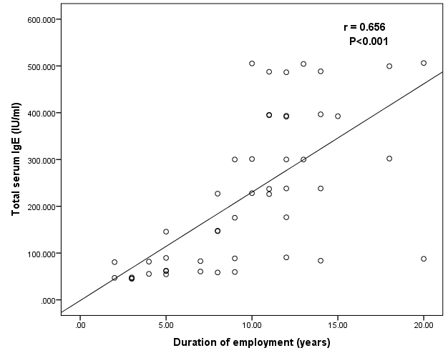

**Figure (1) The correlation between serum IgE levels and work duration among wheat flour mill employees.**

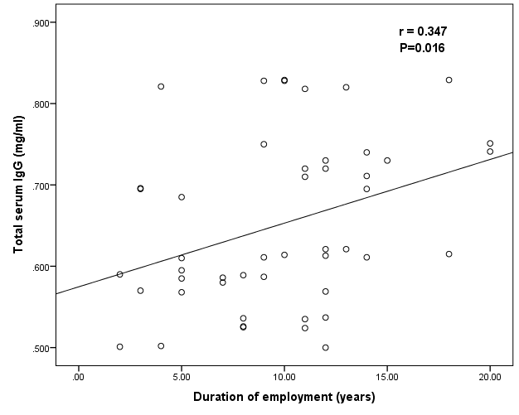

**Figure (2) The correlation between serum IgG levels and work duration among wheat flour mill employees.**

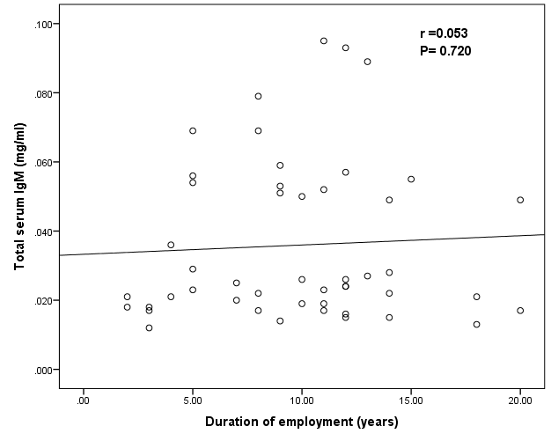

**Figure (3) The correlation between serum IgM levels and work duration among wheat flour mill employees.**

**4- DISCUSSION**

The study found that packing and milling staff had a significant increase in serum IgE & IgM levels (p≥0.05) than the control group (Table 1). This confirms [11-12] findings that wheat flour is a complex organic dust that causes immunological responses in the workplace. [13] Found that organic dust can cause hypersensitivity reactions and harm the immune system. The results may be due to flour mill workers' high allergen dust exposure, which triggers B cells to make antibodies.

Furthermore, the results indicated that the total serum IgG levels of cleaning, Packing, and milling staff were significantly elevated (p≥0.05) compared to the control (Table 1). [14] Increased serum-specific IgE, IgG1, and IgG4 antibodies and work-related respiratory symptoms were observed in employees exposed to wheat flour dust. These results may result from the immune system being stimulated in the mouth due to occupational exposure to wheat flour, which triggers specific reactions.

The results showed that 62.5% of cleaning employees had positive anti-gliadin IgG compared to control and milling employees (Table 2). [15-16] found that people who work in flour mills and bakeries had higher levels of total IgE and gliadin-specific IgG and IgA antibodies. Wheat flour allergies are effectively caused by gliadin and glutenin [17]. This outcome was likely caused by cleaning employees being present at every workstation in the flour mill. As a result, I became immunologically sensitive after being exposed to respirable flour dust and gliadin, the leading wheat allergen, for 8 to 10 hours per day.

In addition, table 3 indicates that cleaning employees exhibited a significantly increased (p≥0.05) nasal eosinophil count compared to packing and milling employees. The results agreed with those of a previous investigation by [18], which found that Eosinophil exudative inflammation in the nose is caused by workplace exposure to flour dust. These findings might be attributed to the possibility that cleaning workers often inhaled large amounts of wheat flour dust. As a result, eosinophils infiltrated the mucous membrane of the nose in response to allergenic rhinitis, which led to allergic inflammation.

The study found that wheat flour mill employees had significantly higher rates of nasal symptoms (e.g., sneezing, itchy nose, runny nose, and catarrh) compared to a control group (p≥0.05) (Table 5). [19] Observed that wheat flour dust is associated with rhinitis symptoms (62%), including sneezing (54.8%) and runny nose (45.2%). Inhaling high amounts of inhalable wheat dust pulses, and other pollutants at work caused upper airway irritation and dust deposits in the upper airway.

In addition, packing employees exhibited higher rates (P≥ 0.05) of nasal symptoms such as sneezing, itchy nose, runny nose, and nasal catarrh compared to Milling employees (Table 5). According to [20], flour mill employees had a higher prevalence of occupational allergic disorders like nasal (47.0%), respiratory (45.9%), and eye (41.6%), suggesting that allergic rhinitis was caused by work-related flour dust exposure.

As shown in Figures 1, 2, and 3, the results also demonstrated a favorable correlation between the period of employment and the total serum of IgE, gG, and IgM in wheat flour mill employees. Similarly, [21] discovered that the time that individuals were exposed to maize dust was significantly correlated with their serum IgG levels. According to their findings, prolonged exposure to grain dust raises IgG, IgG4, and IgE reaction triggers. Additionally, because of the prolonged exposure to wheat flour, [22] showed that the respiratory and allergy problems were more common among flour mill workers. According to the outcomes of this study, continuous contact with wheat dust can potentially affect workers' health and promote their immune systems.

**5- CONCLUSION**

In conclusion, this study showed that prolonged wheat flour dust exposure raises total serum IgE, IgG, and IgM. In addition, cleaning staff had a significantly increased nasal smear eosinophil count among wheat flour mill employees. This result may be attributed to contact employees with high flour dust levels in mills.

**REFERENCES**

1. Khalid, A., Hameed, A., & Tahir, M. F. (2023). Wheat quality: A review on chemical composition, nutritional attributes, grain anatomy, types, classification, and function of seed storage proteins in bread making quality. Frontiers in Nutrition, 10, 1053196. <https://doi.org/10.3389/fnut.2023.1053196>
2. Salcedo, G., Quirce, S., & Díaz-Perales, A. (2011). Wheat allergens associated with baker's asthma. Journal of Investigational Allergology and Clinical Immunology, 21(2), 81–92.
3. Moghaddasi, Y., Mirmohammadi, S., & Ahmad, A. (2014). Health–risk assessment of employees exposed to flour dust: A cross–sectional study of random samples of bakery employees. Atmospheric Pollution Research, 5, 113–118.
4. Ngahane, M., Nde, F., & Ngomo, E. (2015). Sensitization to workplace respiratory allergens among bakery employees in Douala, Cameroon: A cross-sectional study. Allergy, Asthma & Clinical Immunology, 11, 13. <https://doi.org/10.1186/s13223-015-0009-3>
5. Khan, S., Ghanghro, A., Memon, N., Deverajani, B., & Nabi, G. (2015). Investigation of possible allergens in asthmatic employees working in bakeries and flour mills. International Journal of Health Sciences, 5(9).
6. Al-Nama, R. T., Bakr, S. S., & Al-Fyadh, H. A. (2008). Wheat allergy: Immunological study among employees in mill industry in Basrah city. Medical Journal of Basrah University, 26(2).
7. Mapp, C. E., & Boschetto, P. (2003). Occupational asthma. European Respiratory Monograph, 23, 249–259.
8. Tshipukane, D. N., Kembia, E., Lusamb, L., & Nkoy, M. J. (2013). Allergic profile of Congolese individuals exposed to flour dust as compared with a non-exposed work group. Clinical and Translational Allergy, 3(Suppl 2), P9.
9. Chanda, R., Aggarwal, A. K., Kohli, G. S., Jaswal, T. S., & Gupta, K. B. (2002). Comparative study of nasal smear and biopsy in patients of allergic rhinitis. Indian Journal of Allergy, Asthma and Immunology, 16(1), 27–31.
10. Daniel, W. W. (2010). Biostatistics: Basic concepts and methodology for the health sciences (10th ed.). John Wiley & Sons.
11. Kolopp-Sarda, M. N., Massin, N., & Gobert, B. (1994). Humoral immune responses of employees occupationally exposed to wheat flour. American Journal of Industrial Medicine, 26(5), 671–679.
12. Melo, C., Konda, S., Shah, T., & Padwale, I. (2016). Lung function abnormalities in flour mill employees using spirometry. International Journal of Medical Science and Public Health, 5(4).
13. Busch, R. K., Schroeckenstein, D., Meier-Davis, S., Balmes, J., & Rempel, D. (1988). Soybean flour asthma: Detection of allergens by immunoblotting. Journal of Allergy and Clinical Immunology, 82(2), 251–255.
14. Koh, D. H., Kim, H. A., Park, H. J., Ye, Y. M., & Park, H. S. (2007). Prevalence of work-related symptoms and serum-specific antibodies to wheat flour in exposed employees in the bakery industry. Respiratory Medicine, 102(4), 548–555.
15. Bahia, M., Penna, F. J., Sampaio, I. B., Silva, G. M., & Andrade, E. M. (2007). Determining IgA and IgG antigliadin, IgA antitransglutaminase, and antiendomysial antibodies in monkey esophagus and in umbilical cord for diagnosis of celiac disease in developing countries. Journal of Pediatric Gastroenterology and Nutrition, 45(5), 551–558.
16. Khodadadi, I., Abdi, M., Aliabadi, M., & Mirmoeini, E. S. (2011). Exposure to respirable flour dust and gliadin in wheat flour mills. Journal of Occupational Health, 53(6), 417–422.
17. Sotkovský, P., Hubálek, M., Hernychová, L., Novák, P., Havranová, M., Setinová, I., Kitanovicová, A., Fuchs, M., Stulík, J., & Tucková, L. (2008). Proteomic analysis of wheat proteins recognized by IgE antibodies of allergic patients. Proteomics, 8(8), 1677–1691.
18. Storaas, T., Van Do, T., Steinsvåg, S., Irgens, A., Aasen, T., & Greiff, L. (2006). Nasal indices of eosinophilic and exudative inflammation in bakery-employees. Clinical Physiology and Functional Imaging, 27(1), 23–29.
19. Al-Yassen, A. Q. (2009). Occupational respiratory allergic disease among employees in bakeries /Basrah. Medical Journal of Basrah University, 27(2).
20. Ajeel, N. A. H., & Al-Yassen, A. K. (2007). Work-related allergic disorders among flour mill employees. Medical Journal of Basrah University, 25(1).
21. Park, H., Nahm, D., Kim, H., Suh, C., & Kim, K. (1998). Role of specific IgE, IgG and IgG4 antibodies to corn dust in exposed employees. The Korean Journal of Internal Medicine, 13(2).
22. Al-Hakkak, Z. M. M. (2018). Evaluation of prevalence of eyes, skin symptoms and sCD8, sCD86 markers in wheat flour mill workers. Journal of Pharmaceutical Sciences and Research, 10(5), 1161–1164.

**واعراض التهاب الأنف لدى عمال مطاحن الحنطة IgE، IgM، IgGتقييم مستويات الغلوبين المناعي في مدينة النجف الأشرف**

**الـخـلاصـة**

استنشاق جزيئات دقيق القمح في مكان العمل ارتبط بتفاعل الأنف التهابي. هدف هذا البحث دراسة اعراض الأنف بين موظفي مطاحن الحنطة في مدينة النجف.

شملت الدراسة قياس المعايير المناعية، بما في ذلك IgE و IgG و IgM والأجسام المضادة للغليادين IgA و IgG وعدد الخلايا الحمضية في مسحة الأنف، لدى 48 من موظفي مطاحن الحنطة الذكور غير المدخنين (متوسط ​​العمر: 35,83 ± 8,3 سنة، متوسط ​​مدة العمل: 9,22 ± 3,16 سنة) و 37 من غير المدخنين غير المعرضين لغبار الحنطة (متوسط ​​العمر: 35,78 ± 8,66 سنة). بالإضافة إلى ذلك، تم استخدام استبيان موحد، تم تقييم 80 من موظفي مطاحن الدقيق الذكور غير المدخنين لمعرفة الأعراض الأنفية.

تم تقسيم مجموعة الدراسة إلى ثلاث مجموعات فرعية حسب نوع الوظيفة: عمال التنظيف (تعرض عالي)، وعمال التعبئة (متوسط)، وعمال الطحن (تعرض منخفض). أشارت النتائج إلى ارتفاع معنوي (P≥0.05) في مستويات IgE وIgM في مصل الدم لدى عمال التعبئة والمطاحن مقارنةً بالمجموعة السيطرة. كما أظهرت النتائج ارتفاعًا ملحوظًا (P≥0.05) في نسبة IgG الموجبة المضادة للغليادين وعدد الحمضات الأنفية لدى عمال التنظيف مقارنةً بالمجموعة السيطرة وعمال المطاحن. وأشارت الدراسة إلى ارتفاع معدل انتشار أعراض الأنف (P≥0.05) مثل العطس وتهيج الأنف والتهاب الأنف وسيلان الأنف بين الفئات المهنية الثلاث مقارنةً بالمجموعة السيطرة. وأشارت النتائج إلى وجود علاقة مهمة (P≥0.05) بين متوسط ​​تركيزات IgE وIgG وIgM في مصل الدم ومدة عمل عمال مطاحن الحنطة.